COLD CASE FORENSIC PATHOLOGY OF the roman CRUCIFIXION of the rejected messiah_our lord & savior jesus christ
by David Lee Burris

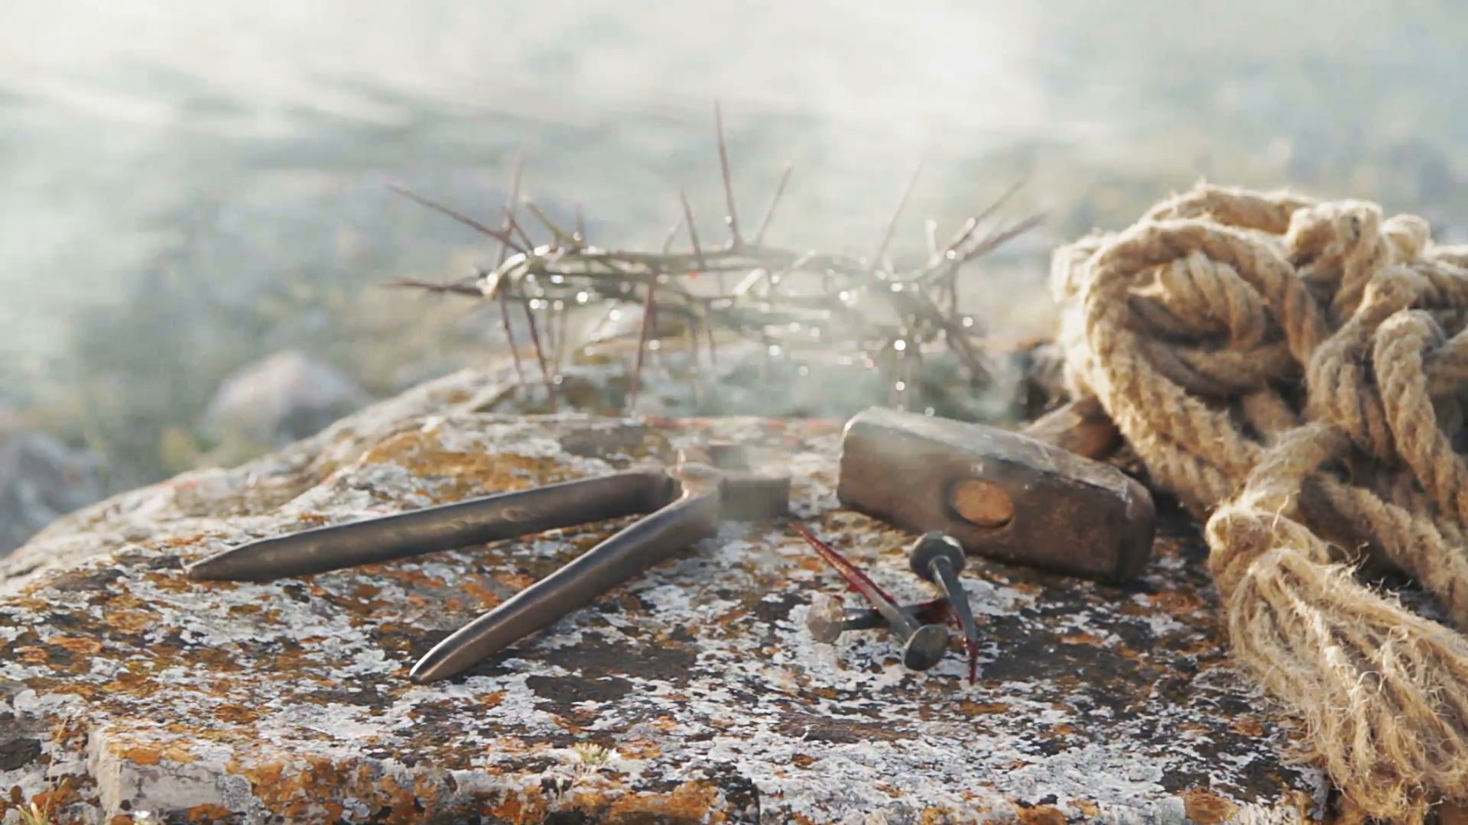
Crucifixion in Antiquity
In ancient societies there were three brutal forms of execution practiced and described as “…crux (crucifixion), crematia (burning), and decollation (decapitation)…” (Retief, 2006). Crucifixion, or impalement, took several forms in antiquity and was “…one of the most brutal and shameful modes of death.” (Retief, 2003). This barbaric form of execution originated with the Assyrians and Babylonians, becoming practiced by the Persians in the 6th century BC, as well as the Carthaginians, Macedonians and Romans. In pre-Roman times Alexander the Great brought this form of execution to the lands of the Mediterranean during the 4th century BC. Crucifixion was thus introduced into Egypt & Carthage where it became a systematic and accepted form of execution (Edwards, 1986).
The earliest form of crucifixion was being impaled on an upright post or tied to a tree (Edwards, 2006). The English word ‘cross’ is from the Latin term ‘crux’. The later ‘cross’, or what became the ‘true cross’, comprised the horizontal cross-bar (patibulum) attached to an upright post (stipes). These crosses came in various forms and sizes. In the Greek of the New Testament there occurred four verbs based on the term stauros or ‘cross’, hence the common parlance stauroo meaning ‘to crucify’. In general terms the word ‘crux’ refers to a framework, a tree, or wood construction for execution. In English the word ‘crucifix’ comes from the Latin crucifigure meaning ‘to fasten to a cross’. The act of crucifixion was copied from the Carthaginians by the Romans. The Romans of antiquity not only employed crucifixion for state enemies, slaves and pirates, but later also for humiliores or members of the lower classes. Victims were suspended by their arms from a cross or similar structure. In other words, crucifixion in the Roman penal practice was used as a means of exhibiting the lower social class victims. The second and first century BC Roman civil wars led to the crucifixion of many as did the destruction of Jerusalem in 70 AD.

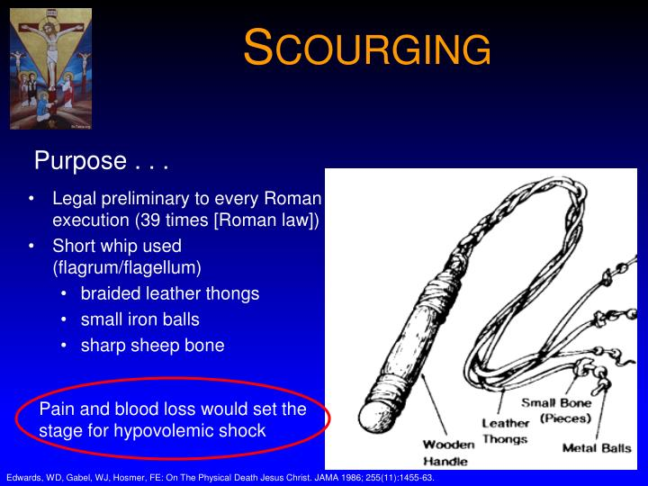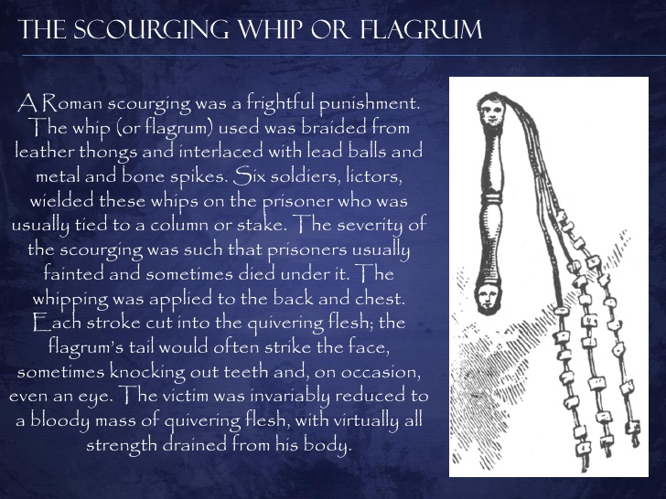
A prelude to crucifixion was the cruel practice of scourging. This flogging was a legal preliminary to all Roman executions (Hengel), the scourging being carried out by two lictors who whipped the victims back, buttocks, and legs with a flagrum (Masien). The instrument of scourging was called a flagellum or flagrum. This instrument was a short whip to which was interwoven sharp pieces or balls attached to braided leather thongs (Edwards, 1986; Masien, 2006). Sometimes wooden staves were also used. Scourging inflicted deep cuts and bruises to skin and underlying muscles with concurrent loss of blood, therefore the “…extent of blood loss may well have determined how long the victim would survive on the cross.” (Edwards, 1986).
In the case of Jesus scourging could have reduced him to a state of pre-shock with haematidrosis. After scourging the victim was made to suffer the burden of carrying the cross-piece or patibulum to the specially designated site of execution or crucifixion (Thomas, 1987). The scourging and execution was commanded by a specialized squad of a centurion accompanied by four soldiers.

The method included positional variations, head up or head down, fixed with nails through the wrists not the hands (Williams). The vertical crucifixion stake was, in Latin, called a crux simplex. Most crosses were of the Latin type, crux immissia, the X-shaped St. Andrew’s cross, the crux decusiata. The crux commissia was the Tau cross consisting of the upright post and the cross-piece form a T-shape. Some of these type gibbets were Y-shaped. The crux immissia is the most common form found in Christian symbol. A low cross was known as the crux humilis and the tall form the crux sublimis. Nailed to the stips post was the inscription called the titulus. Sometimes the victim’s buttocks, according to ancient sources, were supported by a sedile or sedicula that was attached to the upright. If the support was a footrest nailed to the cross, it was called the suppedaneum.

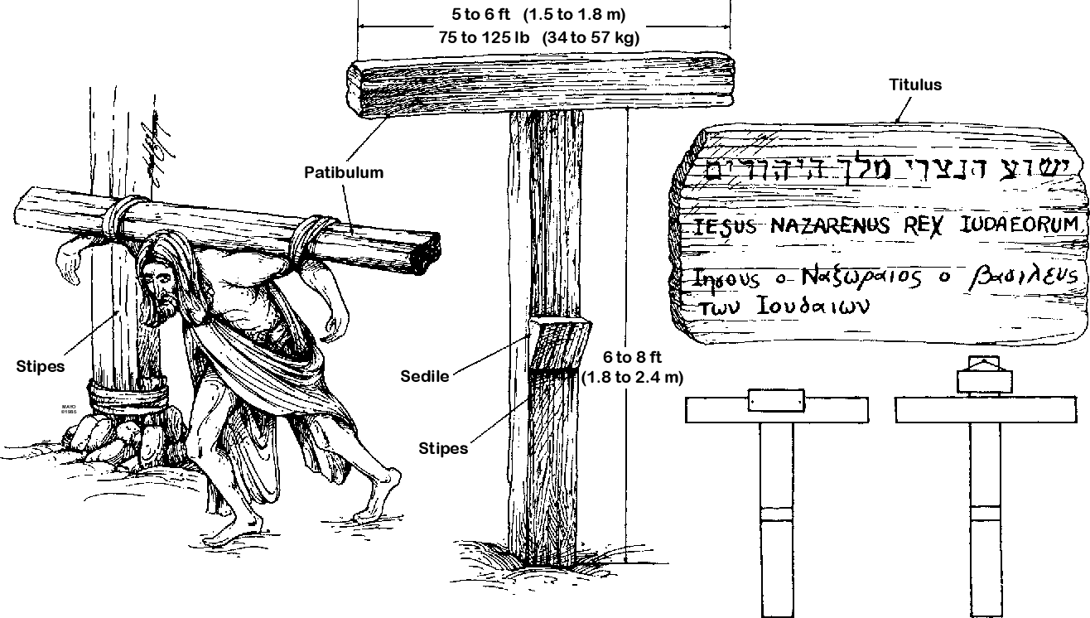

According to the literary sources, those condemned to crucifixion never carried the complete cross, despite the common belief to the contrary and despite the many modern reenactments of Jesus’ walk to Golgotha. Instead, only the crossbar was carried, while the upright was set in a permanent place where it was used for subsequent executions. As the first-century Jewish historian Josephus noted, wood was so scarce in Jerusalem during the first century A.D. that the Romans were forced to travel ten miles from Jerusalem to secure timber for their siege machinery. According to Zias and Sekeles:
“One can reasonably assume that the scarcity of wood may have been expressed in the economics of crucifixion in that the crossbar as well as the upright would be used repeatedly.
According to Zias and Sekeles, the victim’s legs straddled the vertical shaft of the cross, one leg on either side, with the nails penetrating the heel bones. The plaque or plate under the head of the nail, they say, was intended to secure the nail and prevent the condemned man from pulling his feet free.
“Death by crucifixion was the result of the manner in which the condemned man hung from the cross and not the traumatic injury caused by nailing. Hanging from the cross resulted in a painful process of asphyxiation, in which the two sets of muscles used for breathing, the intercostal [chest] muscles and the diaphragm, became progressively weakened. In time, the condemned man expired, due to the inability to continue breathing properly.” – Internet Search Engine

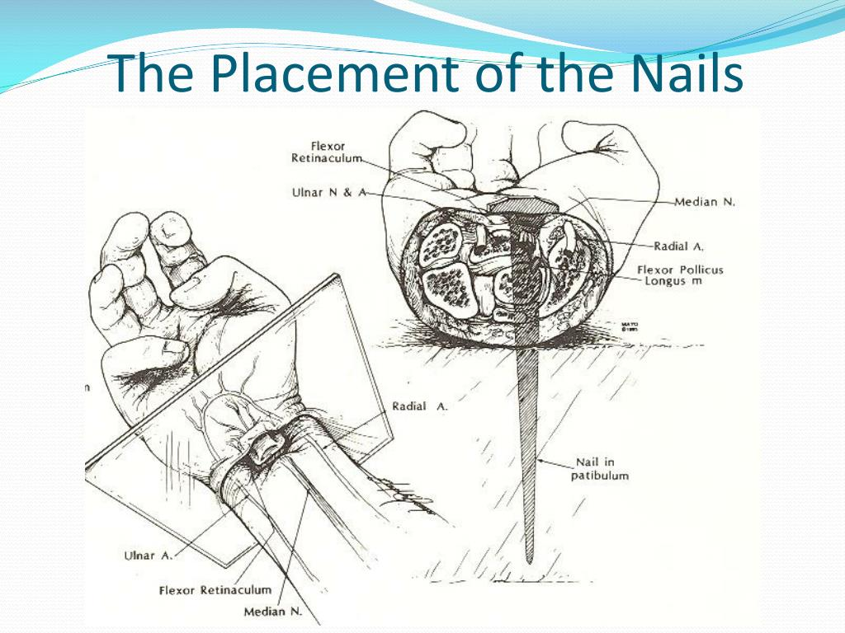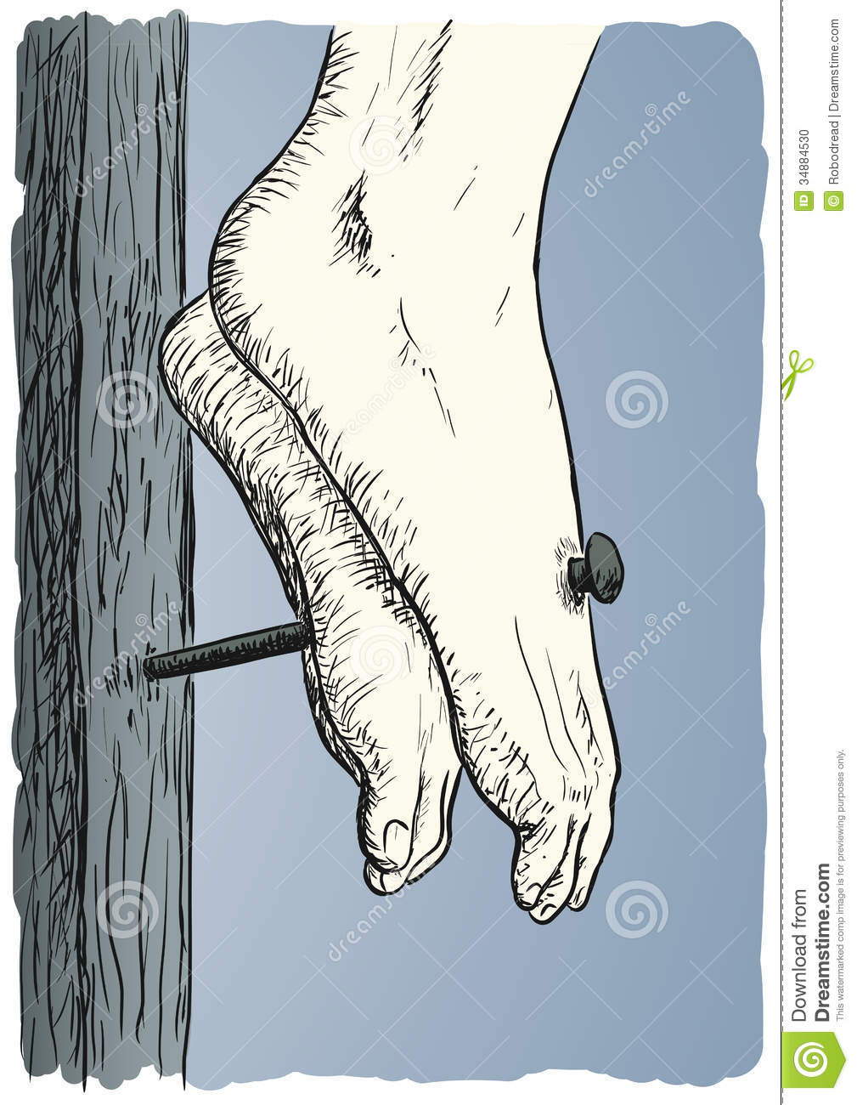
C.A.R.M. - What is the stigmata?
The stigmata are supposed to be the spontaneous appearance of the crucifixion wounds of Jesus on a person’s body. The wounds are alleged to be the same as those that occurred on Jesus’ body - the wounds in the hands, feet, side, scalp (crown of thorns), the back (from being whipped), and face (being beaten). The person who has the stigmata may have only one or all of the wounds.
Typically, the stigmata happen with Roman Catholics near Catholic holidays dealing with the person of Jesus, i.e., his triumphal entry into Jerusalem, crucifixion date, resurrection, etc. But, the Roman Catholic Church has reported stigmata at different times of the year on different people.
Are the stigmata effects real? There is no doubt that different people have spontaneously manifested the wounds that would have appeared in the body of Christ due to his crucifixion. But whether or not these are signs from God or psychological manifestations of the person is hotly debated.
Furthermore, in the real crucifixion of Christ the nails in the hands were not in the palms but the wrists since they considered the wrists to be part of the hand. But we see in the stigmata manifested in Roman Catholics that the wounds occur in the palms and not in the wrists. If the stigmata were real, then they should manifest real physical locations that correspond to the actual wounds of Christ.
Finally, since Roman Catholicism is so filled with superstition, it is probable that the majority of the stigmata that occur with Roman Catholics are the result of self-induced psychological fervor. The human brain is very powerful, and there are numerous accounts throughout the medical field of physical manifestations in the body due to emotional excitement and belief. So, it's with great reservation that anyone should consider the stigmata to be legitimate.
The Crucifixion of Jesus Christ
The standard Roman crucifixion required nailing through the wrists. Most crucifixion victims were impaled naked but women were affixed facing the cross (Thomas, 1987). Nailing the feet to either side of the stipes or to its front meant tying with cords was not required. Nailing of the feet also provided adequate support for the suspended victim, with further support ensured by nailing between the radius and ulna of the forearms.
The crucifixion [Jesus Christ] as portrayed and described thus becomes “…a study in the agony of a man whose arms and legs – their major nerves possibly cut by spikes – shot shearing jolts of pain throughout a body already ravaged by blood loss from severe whipping.” (Parachini, 1986).
The Romans preferred crucifying victims with spikes some 5 to 7 inches in length (Johnson, 1978), with feet affixed either by ropes or nails. In addition, evidence from history and archaeology indicates “…the low Tau cross was preferred by the Romans in Palestine at the time of Christ.” (Edwards, 2006).
Jesus was offered a wine vinegar drink from a sponge on a hyssop stalk -some twenty inches long – which suggests the cross was of the low Tau type.
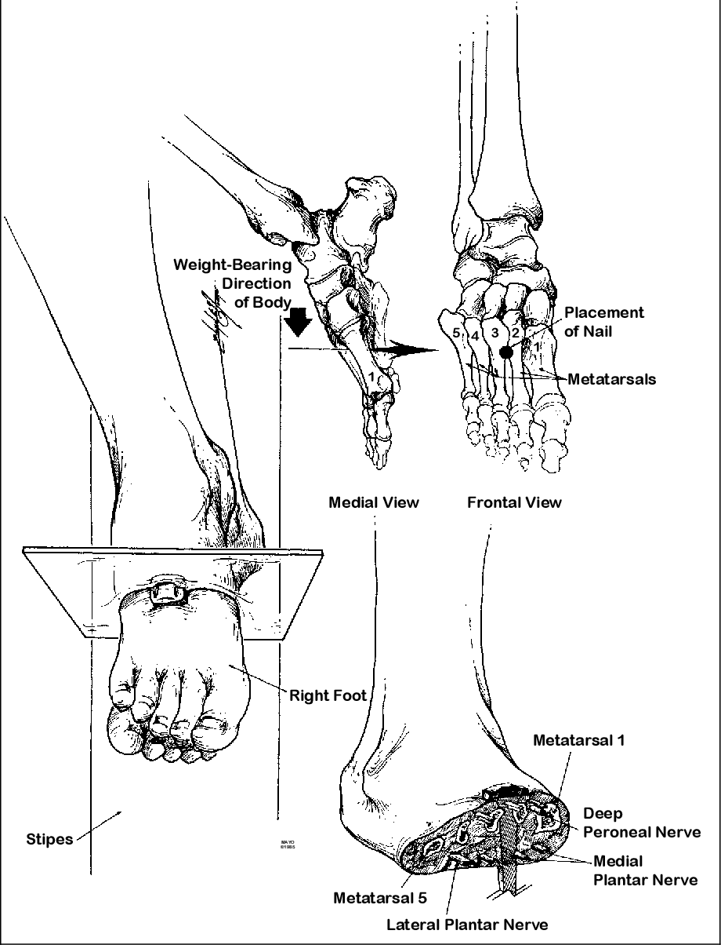
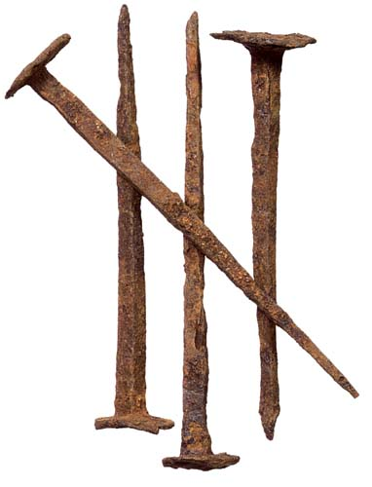

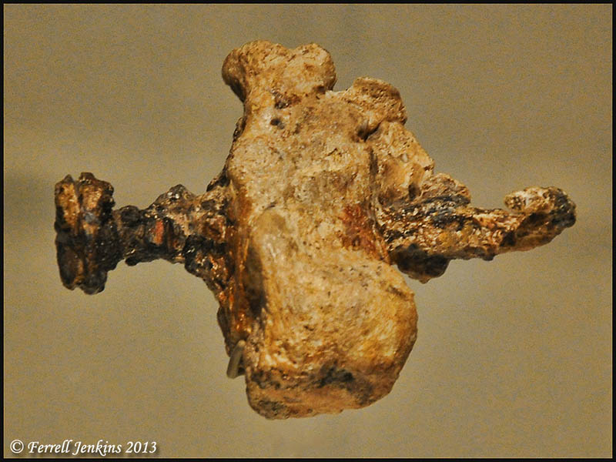

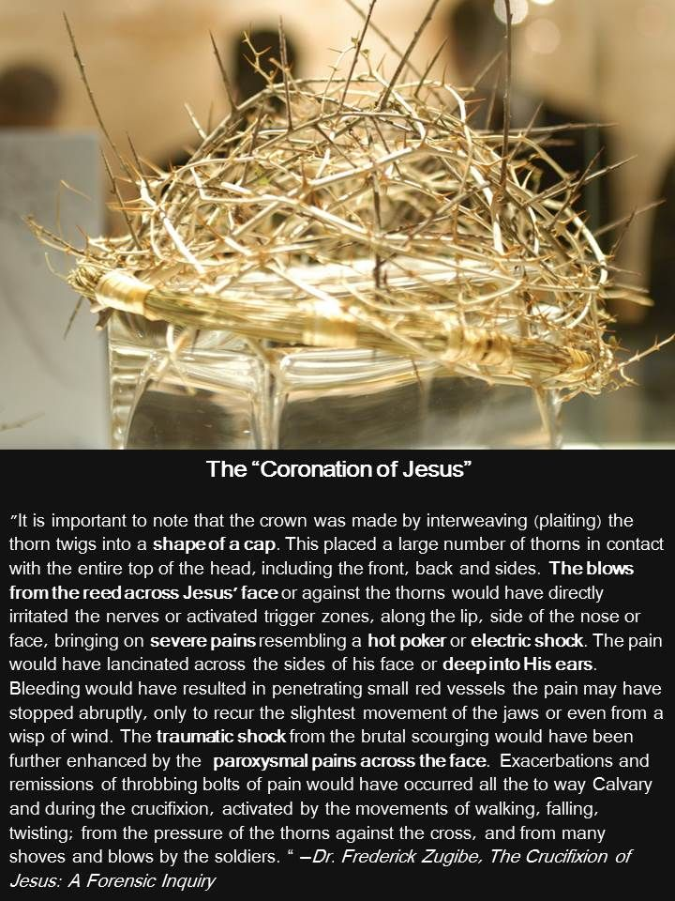

At crucifixion sites the victim was, by law, given a bitter drink of wine mixed with gall (myrrh) as an analgesic (Davis, 1965). The analgesic and narcotic mixture of wine and myrrh was called exactor mortis (Thomas, 1987).
It was customary Roman practice for a crucifixion guard to pierce the side of the victim with a spear or lance (Edwards, 2006). Sources say the spearing caused a watery effusion, of serous and pericardial fluid preceding blood flow (Bucklin, 1970; Davis, 1965). Even though crucifixion was, relatively, a somewhat bloodless practice, guards would hasten death by the breaking of limbs called crucifracture. The Roman guard wouldn’t leave the execution site until it was assumed/assured the victim had expired. An indication of death or its nearness would have been judged also by swarms of flies on bodies as well as the nearing presence of carrion birds (Thomas, 1987).
It is believed that at 3 pm Christ cried out live and died (Johnson, 1978), probably because the major “…pathophysiologic effect of crucifixion was an interference with normal respirations.” (Edwards, 1986) as well as hypovolemic shock and exhaustion asphyxiation.

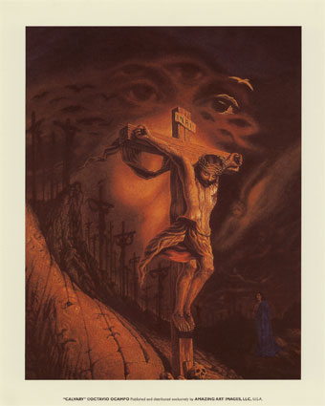

Death Pathology by Crucifixion
With regard to the medical aspects of crucifixion of Jesus Christ a number of theories have been postulated. The ruptured heart theory was put forward in 1847, followed by the asphyxiation theory, cardiovascular collapse, massive trauma, blood loss and dehydration, as well as hypovolaemic or profound shock theory. The number of theories suggests that in reality “…different individuals died from different physiological causes…” (Masien, 2006).
Many physicians have failed to reach agreement on the specific mechanisms of death from crucifixion (Bergeron, 2012) but several hypotheses include: (1) dehydration; (2) cardiac rupture; (3) pleural and pericardial effusions; (4) suspension trauma; (5) fatal spear wounds; (6) cardiac arrhythmias induced by stress; (7) congestive heart failure; and (8) asphyxiation. These contributing factors and postulated causes are all aspects of “…cardiovascular, respiratory, metabolic and psychological pathology.” (Masien). A major factor is traumatic shock that has been “…complicated by trauma-induced coagulopathy…a contributing factor and possibly the primary mechanism…” (Bergeron, 2012).
Hypovolaemia results from a lowering of blood volume resulting from traumatic loss of blood, and was a probable cause of death with exhaustion asphyxia (Lamkin, 1978: Johnson, 1978; Davis, 1965). Hypovolaemic shock was caused by circulatory collapse as well as multi-organ failure.

Further circulatory involvement would or could include a pulmonary embolus due to leg thrombus resulting from immobilised legs. In addition emboli in coronary arteries would have led to myocardial infarction and death.
Crucifracture, the deliberate breaking of the tibiae led to a rapid death, due to asphyxia within minutes. This was known as crucifragium or shelokopia (Edwards, 2006), and was at the time of impending death signified by the not uncommon burrowing of insects into the eyes, orifices such as ears and nostrils, and open wounds of the agonising victims (Cooper, 1883). At this stage of crucifracture death was “…probably commonly precipitated by cardiac arrest, caused by vasovagal reflexes, initiated inter alia by severe anoxaemia, severe pain, body blows and breaking of large bones.” (Retief, 2003).
Asphyxiation could occur during crucifixion when the whole body weight is supported by the arms, causing hyperextension of the lungs and muscles of the chest. In other words, there ensues “…progressive asphyxia caused by impairment of respiratory involvement.” (Retieff) with hypovolaemic shock and anoxaemia the end result. Crucifixion would lead to inevitable asphyxiation caused by diaphragmatic respiration, which implies a “…major pathophysiologic effect of crucifixion, beyond the excruciating pain, was a marked interference with normal respiration.” (Edwards, 2006).

Death from crucifixion occurred between six hours and four days as a result of multifactorial pathology. The length of time between the impalement also ranged from hours to days depending on the method used & the health of the victim. Death was compounded by pre-crucifixion scourging, maiming, shock, pain, dehydration and haemorrhage, leading to death.
Causes of death include “…progressive asphyxia caused by impairment of respiratory movement.” (Retieff, 2006), as well as: cardiac rupture (Stroud, 1871); asphyxia (Barbet, 1953); heart failure (Davis, 1962); arrhythmia (Edwards, 1986); pulmonary embolism (Brenner, 2005); hypovolaemic shock (Zugibe, 2005); as well as acidosis, sepsis, dehaydration, or a combination of all of these factors (Edwards, 1986; Retieff, 2003).
During the Roman period it was not common for anyone to die on the cross within the first few hours (Masien). If the death of the victim happens after only three to six hours then this suggests the “…possibility of a catastrophic terminal event.” (Edwards). The implication is if only after a matter of hours on the cross death occurs, the actual cause is “…multifactorial and related primarily to hypervolemic shock, exhaustion asphyxia and perhaps acute heart failure.” (Edwards). Therefore, death after only a short period is surprising (Lamkin, 1978; Bucklin, 1970; De Pasquale, 1963). Usual crucifixion procedures meant it was “…customary to leave the corpse on the cross to be devoured by predatory animals (Edwards), a process known in ethnography and archaeology as encarnation (Tenney, 1964; Hengel, 1977). – Eric Edwards
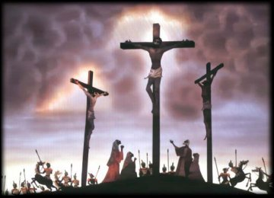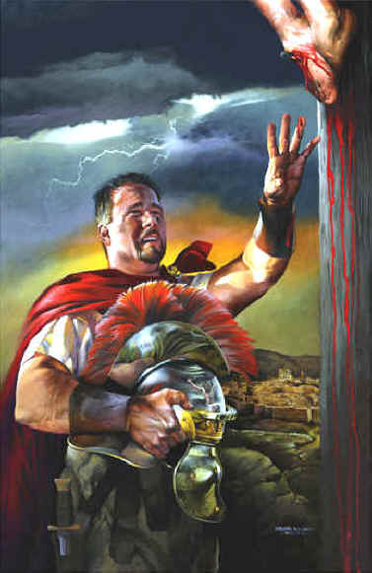
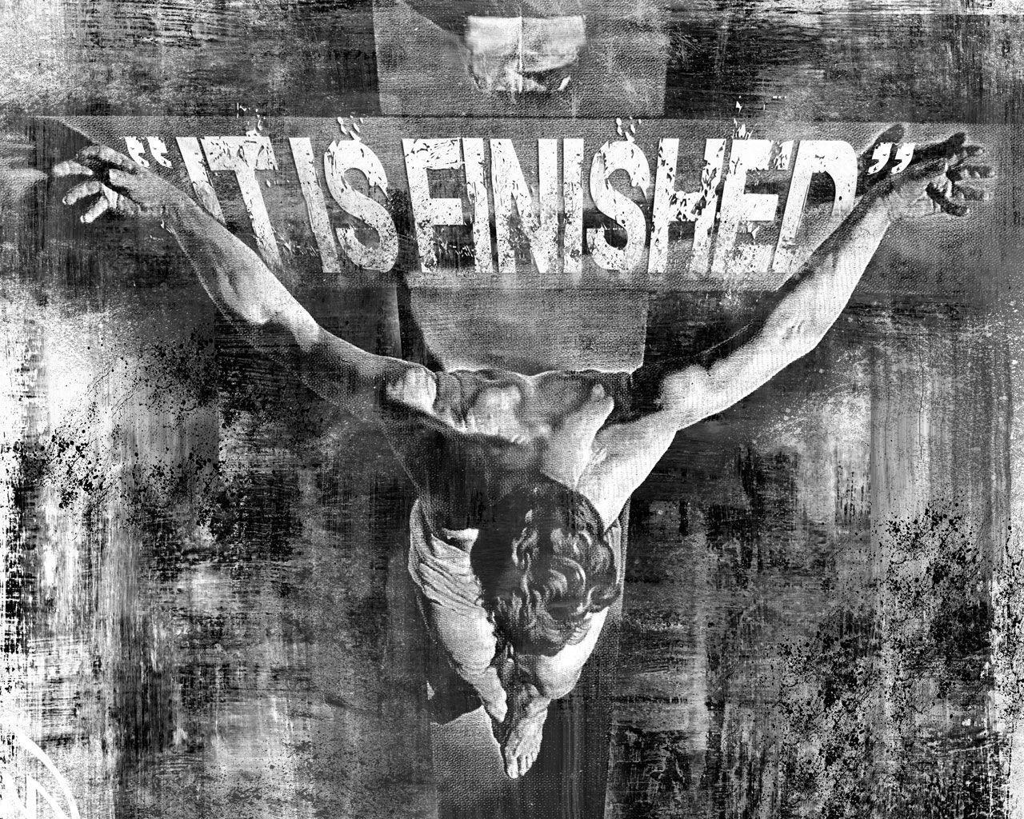

The Last 7 Words of Jesus
1. “Father, forgive them, for they know not what they do” (Luke 23:34).
2. “Truly, I say to you, today you will be with me in paradise” (Luke 23:43).
3. “Women behold your son. Son, behold your mother” (John 19:26-27).
4. “My God, My God, why have you forsaken me?” (Matt. 27:46, Mark 15:34).
5. “I thirst” (John 19:28).
6. “It is finished” (John 19:30).
7. Then Jesus, calling out with a loud voice, said, “Father, into your hands, I commit my spirit!” And having said this he breathed his last (Luke 23:46).

What is the Significance of "It is Finished?"
The Spurgeon Study Bible, a CSB translation, explains,
"'It is finished.' There is only one Greek word for this utterance of our Lord, although to translate it into English, we have to use three words—an ocean of meaning in a drop of language."
Jesus became the final and ultimate sacrifice for our sin. The word in this verse, “finished,” is actually from the Greek word, “tetelestai,” which is the same word that means “paid in full.” Often, it was used in an accounting term, which indicates a debt was paid. The uniqueness about the way it was written is that the tense of the word indicates both a point in time it was complete and that it would also continue to be complete or finished. And this is the essence of what Christ came to do. He came to “finish” God’s work of salvation in us. He came to “pay it in full,” the entire penalty, or debt, for our sins.

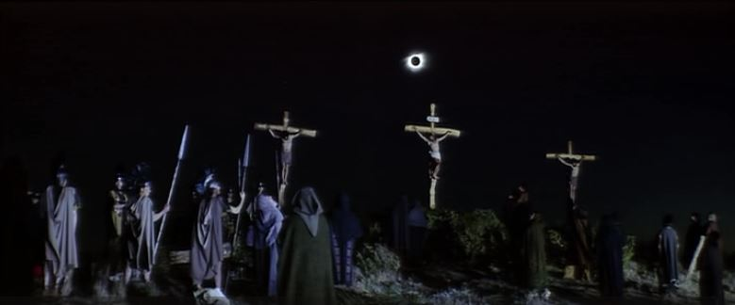

Geological and Historical Evidence for Jesus’ Crucifixion Account

Geological and historical evidence to support the New Testament accounts of Jesus’ crucifixion is abundant, so the intention of this writing is to share this information & provide support for the historicity of Jesus.
At Jesus’ crucifixion, Matthew (27:45-54) reported “From noon until three in the afternoon darkness came over all the land. About three in the afternoon Jesus cried out in a loud voice ‘My God, my God, why have you forsaken me?’ (cf., Psalm 22)…And when Jesus had cried out again in a loud voice, he gave up his spirit. At that moment, the curtain of the temple was torn in two from top to bottom. The earth shook, the rocks split and the tombs broke open. The bodies of many holy people who had died were raised to life. They came out of the tombs after Jesus’ resurrection and went into the holy city and appeared to many people. When the centurion and those with him who were guarding Jesus saw the earthquake and all that happened, they were terrified, and exclaimed, ‘Surely he was the son of God!’”
Matthew’s passage includes two events that can be historically and geologically confirmed: (1) Darkness covered the land for three hours (c.f., Matthew 27:45; Mark 15:33; Luke 23:44-45) and (2) An earthquake occurred.
Historical Extra-biblical Sources for the Darkness
Thallus (52 AD), historian, (as quoted in Julius Africanus “History of the World,” 221 AD)
Africanus states: “Thallus, in his third book of histories, explains away the three hours of darkness as an eclipse of the sun – unreasonably as it seems to me. For the Hebrews celebrate the Passover on the 14th day according to the moon, and the passion of our Savior falls on the day before the Passover, but an eclipse of the sun takes place only when the moon comes under the sun. And it cannot happen at any other time but in the interval between the first day of the new moon and the last day of the old, that is, at their junction: how then should an eclipse occur when the moon is almost diametrically opposed the sun?”

Tertullian (197 AD), Jewish Consul
“At that same moment about noontide, the day was withdrawn; and they, who knew not that this was foretold concerning Christ, thought it was an eclipse. But this you have in your archives; you can read it there. Yet nailed upon the cross, Christ exhibited many notable signs, by which his death was distinguished from all others. At his own free-will, he with a word dismissed from him his spirit, anticipating the executioners’ work. In the same hour, too, the light of day was withdrawn, when the sun at the very time was in his meridian blaze. Those who were not aware that this had been predicted about Christ, no doubt thought it was an eclipse.”
Phlegon (2nd century AD) Greek historian, “Olympiads”
“In the 4th year of the 202nd Olympiad, there was a great eclipse of the sun, greater than had ever been known before, for at the 6th hour the day was changed into night and the stars were seen in the heavens. An earthquake occurred in Bythinia and overthrew a great part of the city of Nicaea.” The 202nd Olympiad is dated between July 29 to June 33.
Origen (184 – 253 AD), Greek scholar and early Christian father who confirmed Phlegon’s writings.
“With regard to the eclipse in the time of Tiberius Caesar, in whose reign Jesus appears to have been crucified, and the great earthquakes which then took place, Phlegon too I think has written in the 13th or 14th book of his Chronicles…Celsus imagines also that both the earthquake and darkness were an invention, but regarding these, we have in the preceding pages made our defense, according to our ability, adducing the testimony of Phlegon, who relates that these events took place at the time when our Savior suffered.”
Julius Africanus (160-240 AD), Christian historian
“Phlegon records that in the time of Tiberius Caesar, at full moon there was a full eclipse of the sun from the 6th hour to the 9th, manifestly that one of which we speak.”
“And about this darkness, Phlegon recalls it in the Olympiads…he mentioned the eclipse which took place during the crucifixion of the Lord Christ, and no other (eclipse), it is clear that he did not know from his sources about any (similar) eclipse in previous times, and this is shown by the historical account of Tiberius Caesar.”
Eusebius (315 AD), Historian of the Emperor Constantine.
“Jesus Christ underwent his passion in the 18th year of Tiberius [33 AD]. Also at that time in another Greek compendium we find an event recorded in these words: ‘the sun was eclipsed, Bithynia was struck by an earthquake, and in the city of Nicaea many buildings fell.”
What Caused the Three-hour Period of Darkness?
Before determining that the three-hour period of darkness is due to supernatural causes, we must rule out the natural possibilities. We have experienced natural events that have caused darkness during the daylight hours. These include when volcanoes erupt and emit dark clouds and when storms occur and cover the sky with clouds. Yet no Biblical or secular sources indicate any support for a volcanic explosion or storms, so we can rule out those two natural events.
What about an eclipse? The positioning of the sun and moon is required to answer this question. We have much support for the dating of Jesus’ crucifixion on Friday the 14th of Nissan in the year 33 (April 3, 33). This date was further predicted in the book of Daniel (9). Passovers only occurred during a full moon, so an eclipse would not have been possible due to the moon’s location on the far side of the earth away from the sun. Even if the positioning were conducive to an eclipse, eclipses only darken the earth for short moments, not for three hours, so we have another reason to rule out that natural option.
Is the Best Explanation to this Event that of a Supernatural Explanation?
I will let readers answer that question for themselves.
Geological Support for the Earthquake
Scholars have reported that devastating earthquakes occurred in Jerusalem during Christ’s death (Mallet, 1853; Rigg, 1941). This occurred in a region that includes the Dead Sea fault, which is a plate boundary that separates the Arabian plate and the Sinai sub-plate (Garfunkel, 1981). This fault has been active since the Miocene (Kagan, Stein, Agnon, & Neuman, 2011) and the fault is still active today (De Liso & Fidani, 2014). The fault extends from the Red Sea in the south to the Taurus Mountains in the north.

Kagan and colleagues (2011) analyzed seismites in the Holocene Dead Sea basin by constructing two age-depth chronological models based on atmospheric radiocarbon ages of short-lived organic debris with a Bayesian model. Seismites are sedimentary beds and structures, which are deformed by seismic shaking. The scholars analyzed seismites in different areas of the basin, finding that several synchronous seismites appeared in all sections during particular years, including 33 AD (+/- 2 sigma; 95% confidence interval). Other years in which earthquakes occurred as evidenced by seismites are (AD unless otherwise noted): 1927, 1293, 1202/1212, 749, 551, 419, 33, 31 BC, and mid-century B.C.
After analyzing laminated sedimentary cores recovered at the shores of the Dead Sea, Migowski, Agnon, Bookman, Negendank, and Stein (2004) also confirmed an earthquake in 33 AD with a magnitude of 5.5. They documented earthquakes around 33 AD in 31 BC and 76 AD. The scholars analyzed seismites using radiocarbon dating.
Ben-Menahem (2014) conducted a literature review of empirical studies over 4,000 years of seismicity along the Dead Sea Rift. The scholar referenced the aforementioned studies along with one by Enzel, Kadan, and Eyal (2000) before concluding that earthquakes occurred in Masada in 31 BC, Jerusalem in 33 AD, and near Nablus in 64 AD.
In summary, the literature on seismicity along the Dead Sea basin supports the assertion that an earthquake occurred either in or very close to the year 33 AD.
We can pinpoint the date even closer – to April 3, 33. A United States government federal agency, the National Oceanic and Atmospheric Administration, has documented the major earthquakes throughout history. According to their website (NOAA.gov), in 33 AD, an earthquake occurred at the crucifixion of Jesus Christ in Bithynia and Palestine and Palestine, Jerusalem.
Conclusion
In summary, we have extensive extra-biblical support for the accounts of darkness and the earthquake during Jesus’ crucifixion. Taken together, these events support the historicity of the account of Jesus’ crucifixion.

