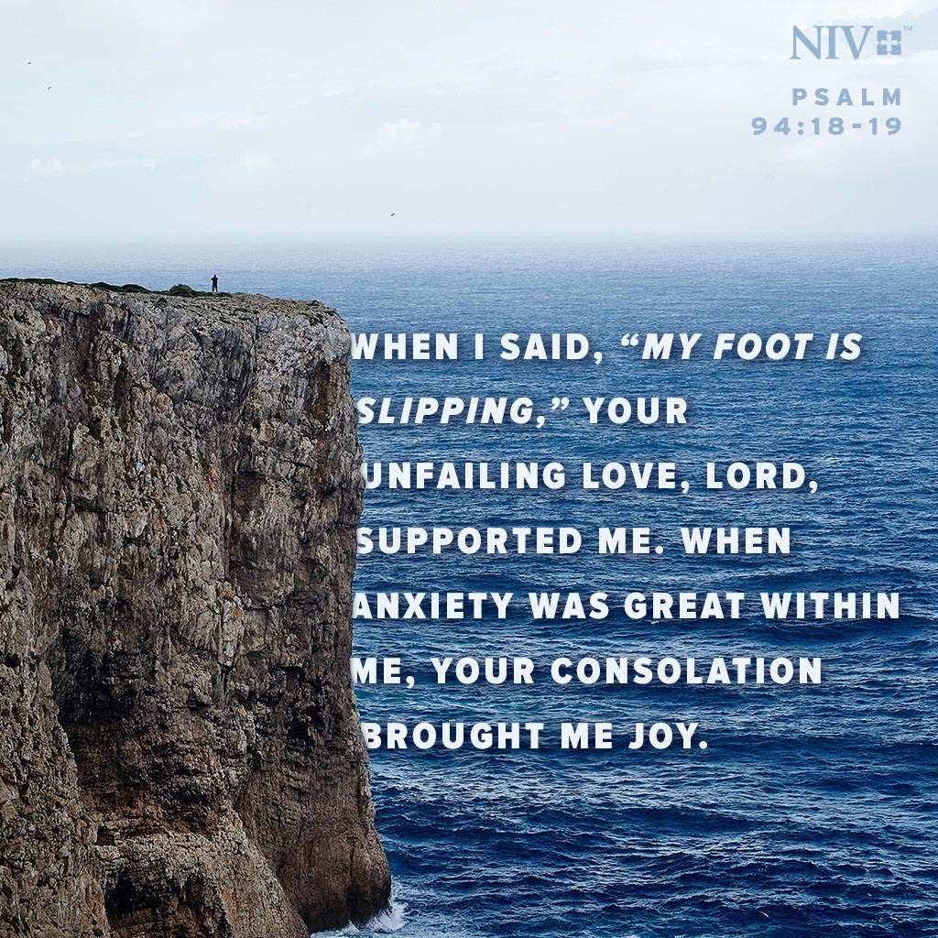HOW IS YOUR PRAYER LIFE?

Is it as good as David’s? He had to be a man of prayer to be called a “man after God’s own heart.” David, along with Heman the Ezrahite, provide a good prayer plan for us in a number of the Psalms.

Psa. 88:13 “But I, O LORD, have cried out to You for help, and in the morning my prayer comes before You.”
Do you begin your day with prayer? In the darkness, before you even get up?
Are you thankful to God for another day. It is a dangerous thing to start the day without talking to God about it.

Psa 141:2 “May my prayer be counted as incense before You; The lifting up of my hands as the evening offering.”
Likewise, it is a dangerous thing to end a day without talking to God. Many of us have ended our day with prayer from the time we were small. Hopefully, we still do that, but it should be that our prayers have matured through the years.
We ought to end the day, not knowing if we will see another one, with a humble, sincere, thankful prayer for the blessings of the day just passed and for care through the night to come.

Psa 55:17 “Evening and morning and at noon, I will complain and murmur, And He will hear my voice.”
Morning and evening are certainly good times to talk to God. But noon is also. In fact, anytime is good. Do you talk to God throughout the day, even when things are not going well, as David does in the verse above? It may not be a prayer of thanksgiving, but a prayer of deep pain, sorrow, despair. Even so, and maybe more-so, God still longs to hear from you, often, and He will listen to you.

Psa 88:9 “My eye has wasted away because of affliction; I have called upon You every day, O LORD; I have spread out my hands to You.”
Have you ever gone a day rarely speaking to God, or not talking to Him at all? We all long to hear the voice of our family, our children, our grandchildren. So does God. He never goes a day, or a minute, or a second, without eagerly waiting and wanting to hear your voice.

Psa 16:8 “I have set the LORD continually before me; Because He is at my right hand, I will not be shaken.”
God is always near, ready to hear your prayer. No matter the circumstances, good or bad, God is always listening for your voice.
When you find yourself in a new situation – happy, excited, overwhelmed, disappointed, sorrowful. What is your first reaction?
It ought to be prayer. Talk to God about it.
Whatever happens in life, it is always important to first talk to God about it with thanksgiving, for guidance, comfort, strength. He is always there.

But to talk to God in prayer you must be in the proper relationship with Him. And that relationship is attained only through the Gospel of Jesus Christ. And that Gospel is found only in the New Testament and is taught and practiced by His church.

