THE LOSS OF CHILDHOOD INNOCENCE
by David Lee Burris
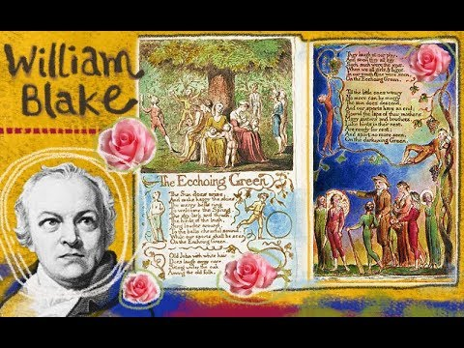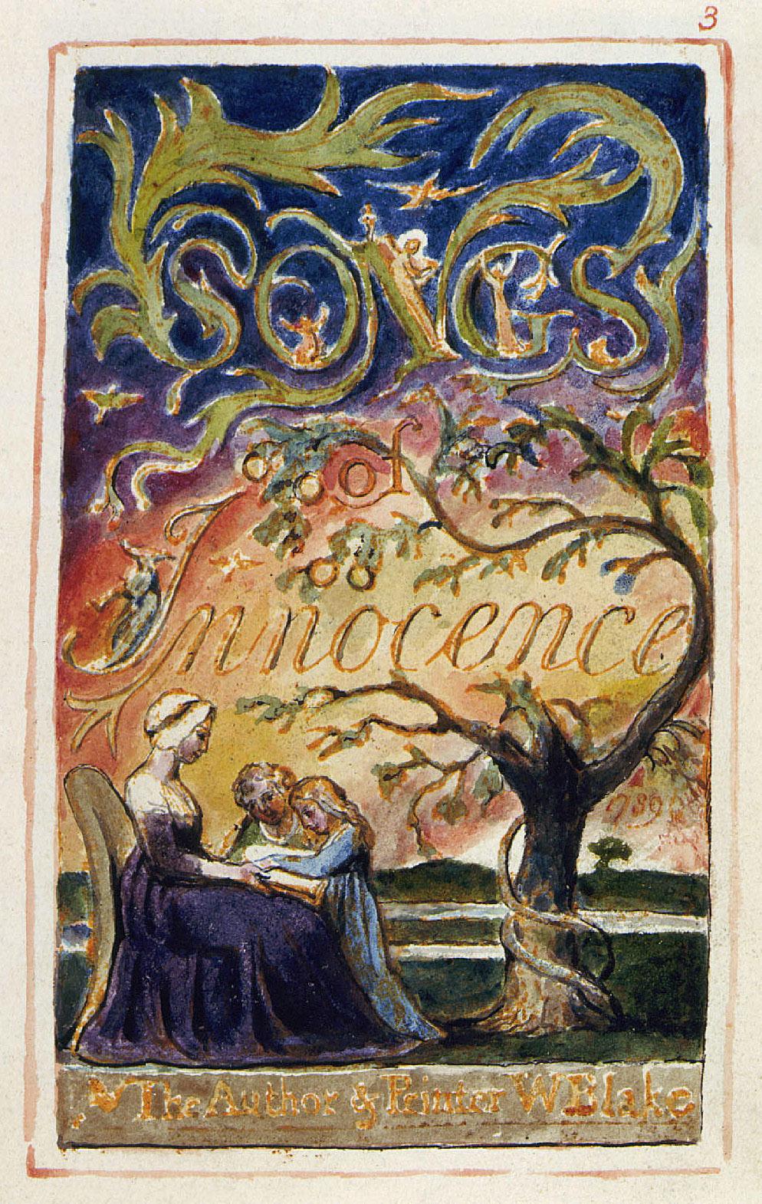
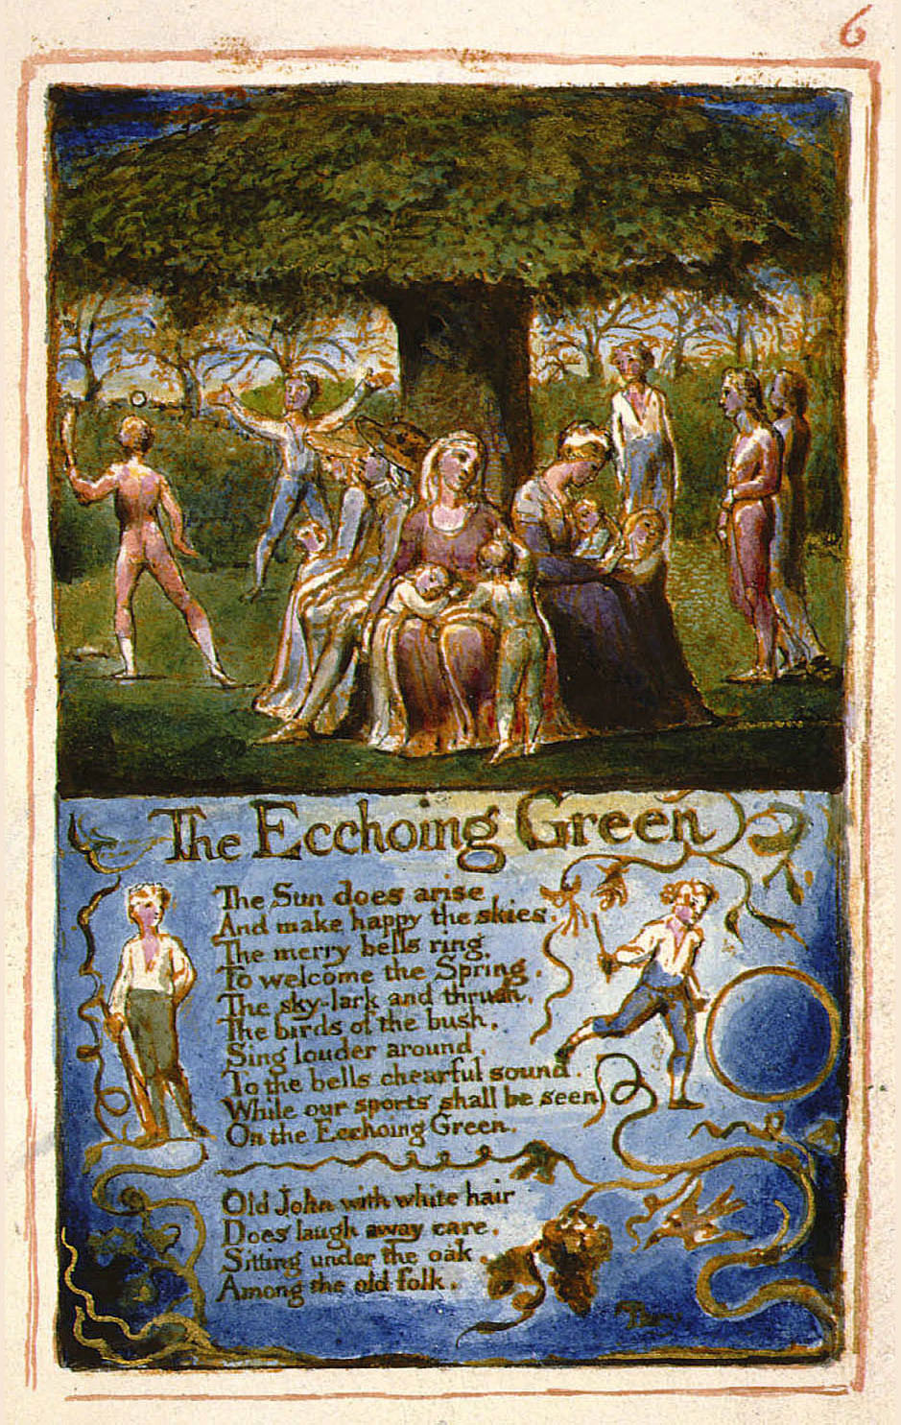
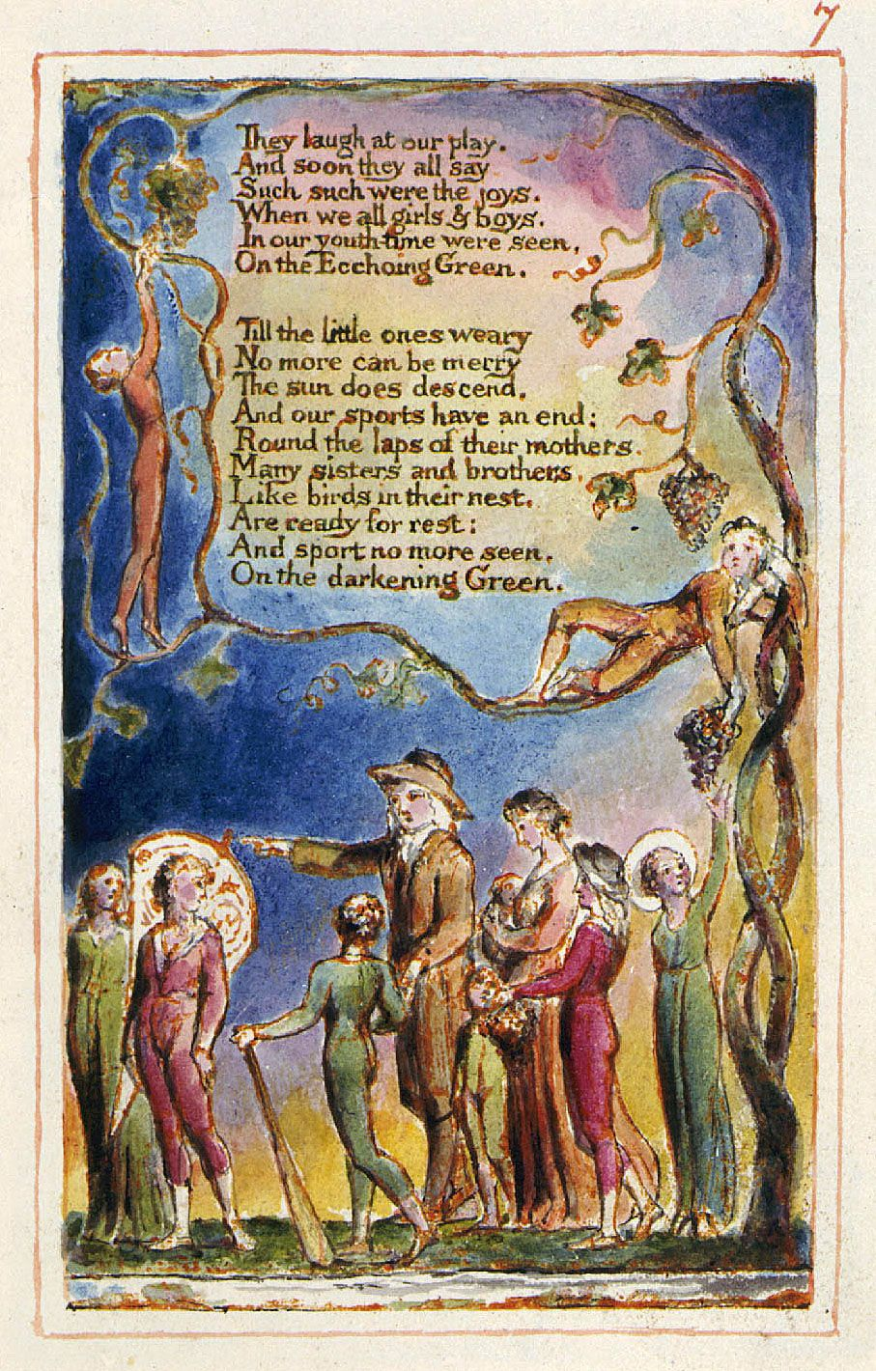
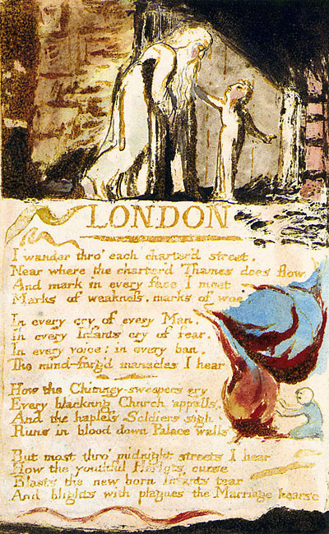THE GARDEN: GOOD, EVIL, AND THE LOSS OF INNOCENCE

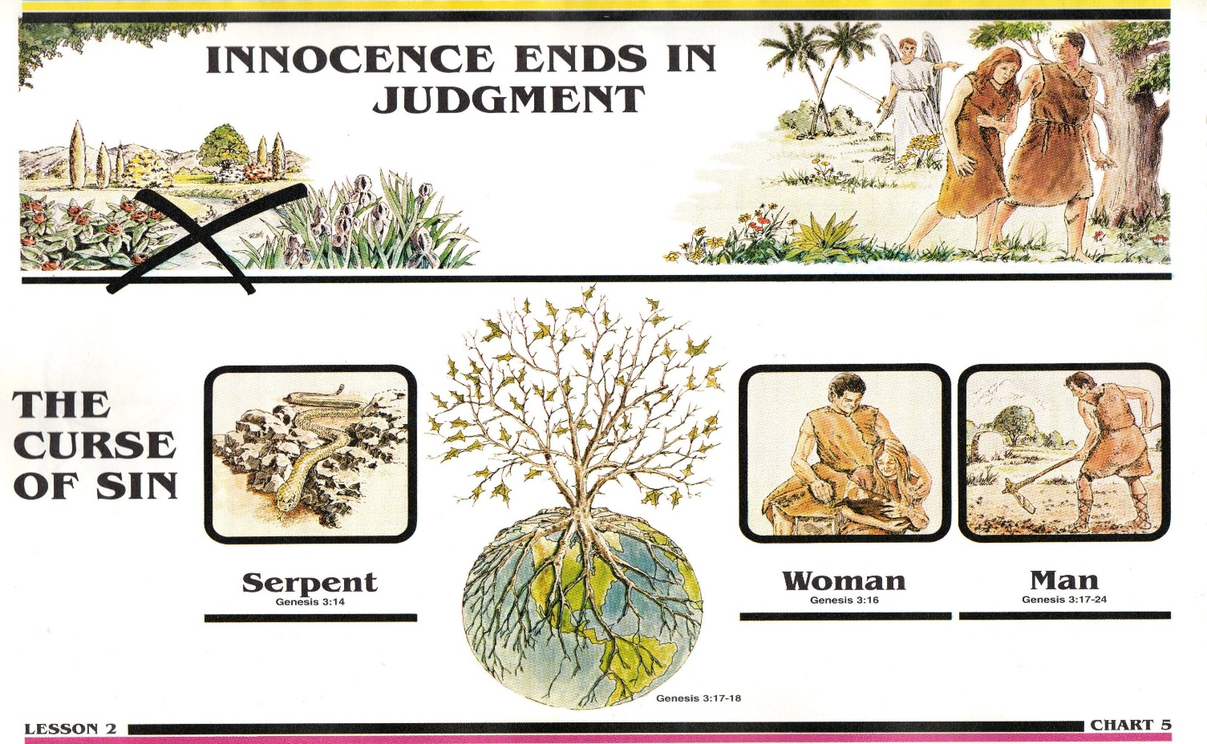
A good place to begin is Eden. The story of Adam and Eve is a tale of good and evil, of shame and the loss of innocence. When Eve eats the fruit from the tree of knowledge of good and evil, when she "succumbs to temptation and Adam joins in disobedience," they acquire the knowledge of good and evil and grasp that they are naked. With this enlightenment, they lose their innocence and experience shame before one another. The light from the garden reveals shame and the loss of innocence.
Shame is often confused or merged with guilt. Shame, however, is a distinct moral feeling that is stirred not by wrongdoing, as is guilt, but by the failure to live up to a moral ideal. Theologian Dietrich Bonhoeffer offered one of the most eloquent definitions of shame: Shame is man's ineffaceable recollection of his estrangement from the origin; it is grief for this estrangement & the powerless longing to return to unity with the origin. Man is ashamed because he has lost something which is essential to his original character, to himself as a whole...
Shame implies a positive attachment that is threatened by the failure to live up to some moral ideal. Shame, then, is relational, the consequence of a failure to be human as one aspires to being human. In shame, one's own human self is exposed: Adam and Eve see they are naked and cover themselves.
In guilt, Adam and Eve might atone for their wrongdoing. In shame, on the other hand, they must transcend the shame by achieving the moral ideal. The difficulty of the garden is that the moral ideal we must aspire to is the very thing that was lost in the garden: innocence.
Moral philosopher Herbert Morris wrote about the loss of innocence. Morris argued that innocence is lost of an instant, much as a liability to shame is acquired, because of an insight into the nature of human beings: "The objects of the knowledge embodied in lost innocence are human beings." In coming to know about human beings, we come to know of the presence in the world of good and evil. In fact, Morris argued that the loss of innocence necessarily involves the painful experience of evil. Evil, as Morris defined it, is anything for which human beings are believed responsible that in some way is seen destructive of what is of relatively great value. [Evil] includes ... failing to promote what is of value, preventing its promotion and actually destroying what is of value. What would then account for some conduct being wrong would be the evil that it causes.

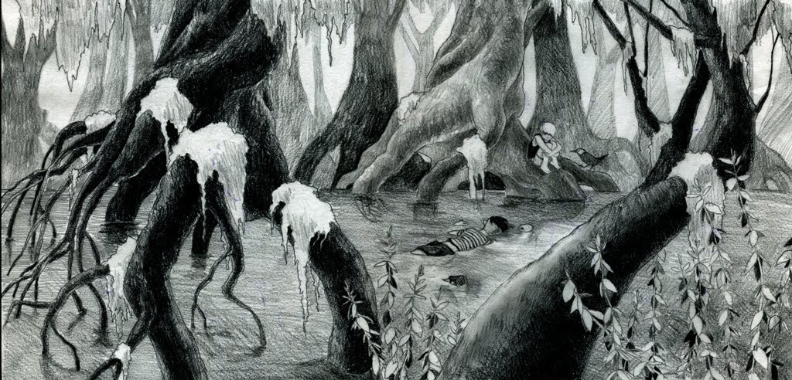
Shame, then, is a moral feeling prompted by the loss of innocence and can be understood as an experience of evil. Evil, the loss of innocence, and shame involve the painful recognition in ourselves of this capacity, this something we do not love but hate, and the recognition in others of the same capacity in relation to us that we hate and do not love. The end result is that loss of innocence gives us a knowledge, then, not of what is right and wrong or the set of dispositions to act & feel in certain ways connected with this knowledge, but a knowledge of evil and the set of dispositions to act and feel that are connected with this knowledge.
With the loss of innocence, we become conscious of our vulnerabilities. We guard ourselves against the pain of the evil we believe we may do or may be done us, and, like Adam and Eve, in shame, we cover ourselves.
When Adam and Eve lost their innocence to the experience of evil, they also acquired knowledge of the good. Knowledge of the good would ensure that innocence was always remembered and could be counted upon, as shame requires, to transcend evil. Morris made a similar point:
To appreciate that there is evil in the world, to hold no illusions about it, to be serious about it, to have experienced its many manifestations, to have seen as well as evil what allows for its being overcome, to see all that makes for the good and to give it due weight - these seem among the essential components of moral wisdom. Thus, moral wisdom involves not accepting the legacy of exile from the garden as written, but finding the way to transcend evil.
Immediately after the fall, after Adam and Eve are expelled from the garden, "comes the story of jealousy and rivalry, of rage and sin - the murder of Abel by Cain. Here emphasis is not on opening eyes, exposure, and hiding, but on sin[,] ... on controlling the aggressive drive…, on being overwhelmed by it, on murder, blood, and retaliation."
The moral foundation of this part of the story is not shame and the loss of innocence, but, rather, guilt and the transgression of prohibitions. In guilt, innocence does not speak to some inherent human quality that might be lost in an instant, but rather simply to one's not being responsible for a particular wrongdoing.
Shame and loss of innocence are about relational aspects of being human which prompt transformation of the self to transcend evil.

– Kate Day
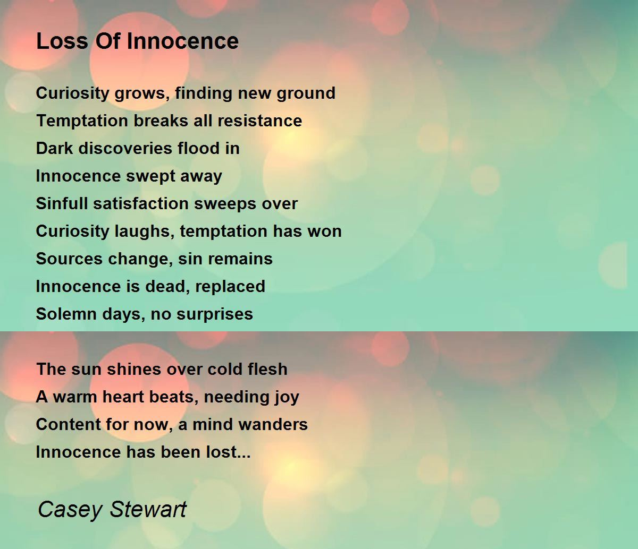
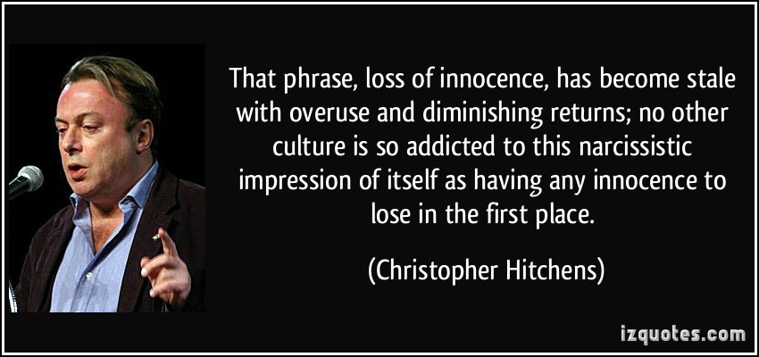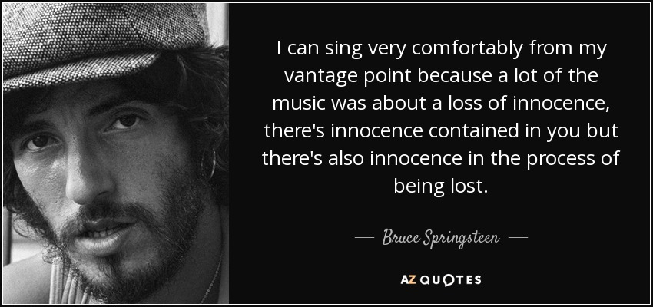
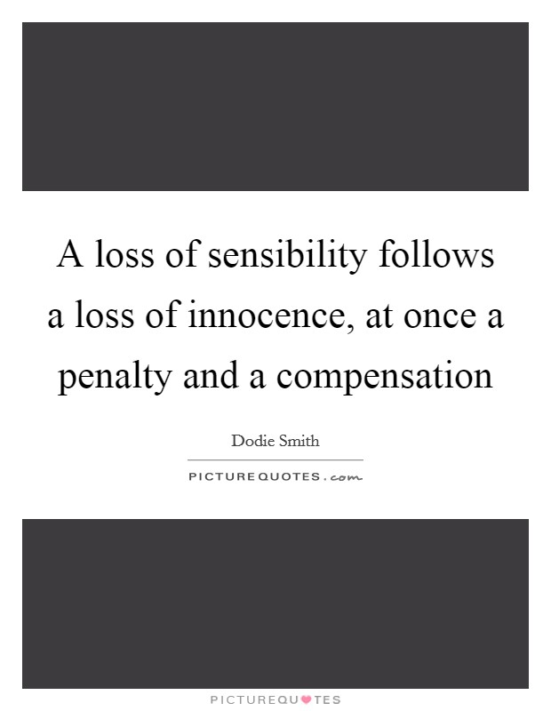
THE LOST GENERATION

The term “lost generation” came from a statement. “All of you young people who served in the war. . . . You are all a lost generation,” writer Gertrude Stein said to a young Ernest Hemingway in the years after World War I, according to his account years later in A Moveable Feast.
The phrase “lost generation” described the disillusionment felt by many, especially intellectuals and creatives, after the death and carnage of World War I. The loss of faith in traditional values and [Victorian] ideals led many who came of age during the First World War to become hedonistic, rebellious, and aimless — “lost.” This cynicism and disillusionment defined the literary & creative landscape of the 1920s.

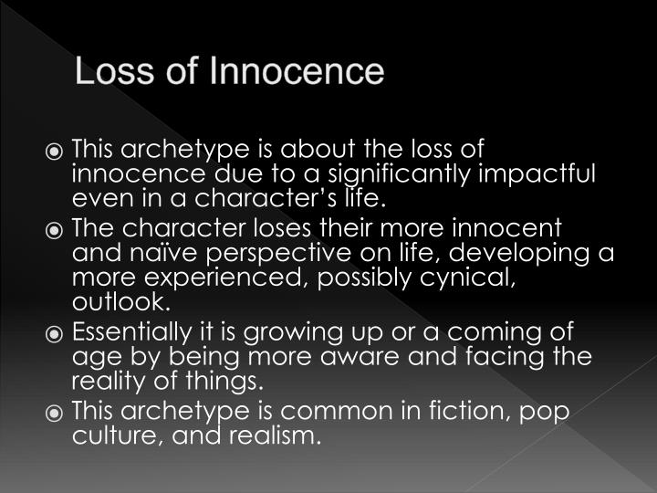
Excerpts Touchstone’s: “In Defense of Prudery”

The Wisdom of the Victorian Quest for Innocence by David Sandifer
One may justly speak of an "ethic of innocence" as one of the defining aspects of the culture of the Victorian period. The Victorian quest for innocence in fact reflects something much more profound: the flowering of a deeply Christian vision of sexuality into broad cultural norms. In a society bent on normalizing perversion and marginalizing purity, it is a vision that twenty-first-century Christians would do well to study.
The upper classes no longer flaunted their excesses, and the lower classes, in their quest for respectability and under the growing Wesleyan influence, moderated their coarseness and lewdness.
Social reformer Francis Place meticulously documented the changes that had taken place in one generation among the working classes, noting, for example, that the lewd songs that were commonly sung in his youth "have disappeared and are altogether unknown."
Societies for the reformation of manners had existed since the late seventeenth century, attempting with various degrees of success to bring moral reform. The eighteenth century had seen the rise of a "culture of sensibility," expressed in the likes of Samuel Johnson, which sought to soften and refine the mores of the middle and upper classes. Most significantly, the British Great Awakening—had acted as a spiritual leaven throughout British society, eventually reaching its most elevated stations by the late eighteenth century. William Wilberforce famously identified a "reformation of manners" as one of the "two great objects" that God had set before him.
Three Pivotal Beliefs. In the first place, the Victorians inherited a view of human nature that saw moral traits as radically plastic. This meant that every book, every play, every conversation, indeed, every aspect of one's everyday environment, was viewed as contributing either positively or negatively toward the development of one's character. While Locke had famously referred to this in terms of a "blank slate," a more frequently used image to describe this pervasive dynamic was that of the garden: it will grow either weeds or flowers, depending entirely on what is sown — and it will not grow nothing. "Culture" (it is easy to forget the derivation of the word) thus consists in implanting the right sorts of things and in keeping the wrong sorts away.

Media in particular were viewed as having a decisive effect in the shaping individuals and society, with Thomas Carlyle going so far as to argue that the influence of books and periodicals exceeded that of the pulpit, and likening their authors to a "priesthood."
Second, the arts were viewed as existing first and foremost for our moral improvement. This wasn’t a matter of making art mercenary; our present assumption that aesthetics and morality are independent realms—a view that gained ascendancy with the Aesthetic movement of the 1870s—would have been unfathomable to most people in the early nineteenth century. Most assumed that art which tended to corrupt was simply bad art.
Finally, Victorian society increasingly came to venerate marriage and family, an attitude that had been characteristic of Evangelicals since the British Great Awakening. Marriage was conceived as the greatest good of earthly life, out of which flowed all manner of other goods, both for individuals and society. It was the key both to personal happiness and to societal order and progress.
Marriage was thus both a source of moral and spiritual energy, and prophylactic against temptation. It followed from this that anything that would undermine marriage was felt to be supremely dangerous, and so sexual immorality was singled out as especially pernicious. For Harriet Bowdler, seduction was a sin worse than murder, since "those who kill the body have no more that they can do," whereas the seducer would rob his victim of her virtue as well as "perhaps her eternal happiness."
As any reader of Jane Austen will know: a young woman of good standing who fell into an illicit relationship was likely to see her future options dramatically and irretrievably curtailed.
Instead, representations of sexuality that were coarse or sanctioned immorality were seen not only to weaken resistance to vice, but also to sully the soul, to desensitize the conscience, and, ultimately, to dehumanize—debasing sex by divorcing it from its properly elevated context. Herein lay the justification for keeping certain sins hidden as much as possible, since the mere knowledge of them altered the moral landscape for the worse. When Lord Desart objected to a proposed provision in Parliament against lesbianism, he expressed his objection in characteristically Victorian terms, even if the year was 1921: "You are going to tell the whole world that there is such an offence, to bring it to the notice of women who have never heard of it, never thought of it, never dreamt of it. I think this is a very great mischief."

Seen in this light, the censuring of sexual content for the purpose of protecting moral innocence was neither priggishness nor hypocrisy.
Far from being inimical to sexual love, modesty is a prerequisite for it, creating a protected space that allows the fusion of the physical with the relational: full sexual pleasure is impossible without it.
The example of our Victorian forebears should give us pause, however. They lived in a world where media were both much less pervasive and much less perverse, and yet they were deeply aware of their own vulnerability to corruptive influences.
Yet they offer us a bracing reminder of the truth that the battle for sexual purity begins in the mind. It wasn’t they, but Paul, who enjoined us to be "innocent of evil" (Romans 16:19) and to think on "whatever is pure, whatever is lovely" (Philippians 4:8). It was not they, but our Lord, who commanded us to pluck out the eye that offends (Matthew 5:29).

The standard they often employed in judging a play or book was whether or not it was mind "improving," recalling Paul's injunction that "all things are lawful, but not all things build up" (1 Corinthians 10:23). Adopting this principle for our lives would mean approaching our choices for media consumption as something like curators: each of us is charged by God with the delicate and vital task of determining which words and images ought to fill the collection which is our mind.

*********************************************************
19th Century Wide-Scope Failure
20th Century Narrow Focus Wins

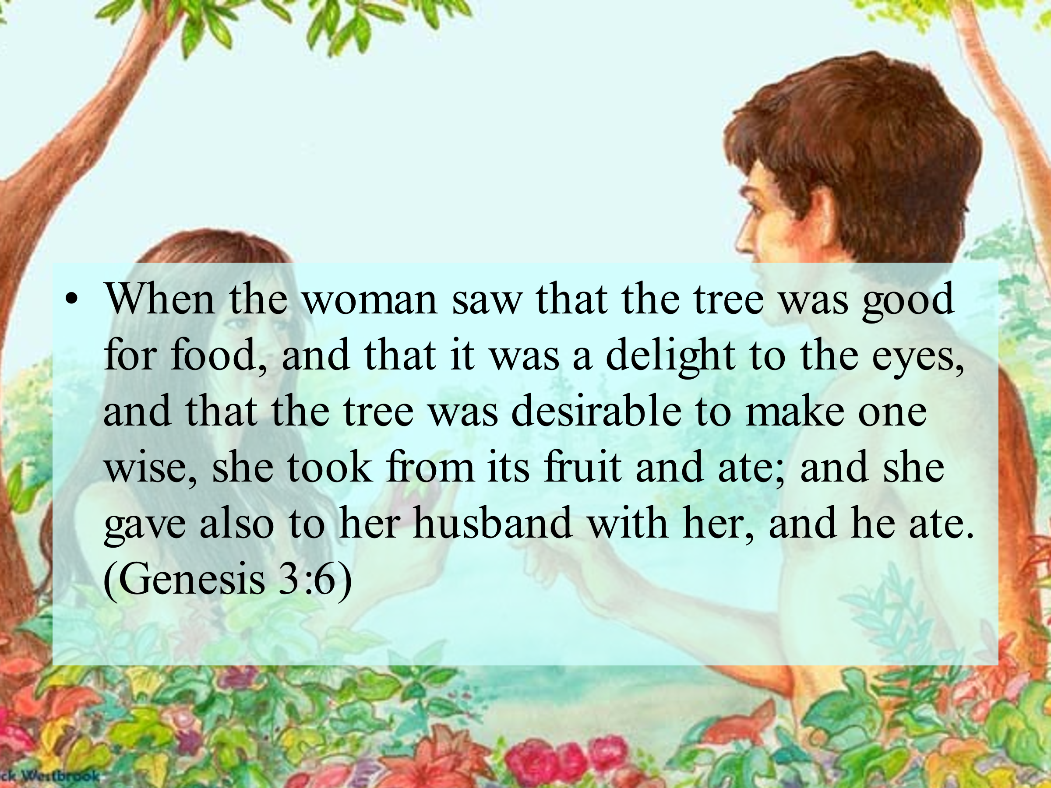
Youthful Inexperience Temptation Susceptible

We learn from them & They learn from us.

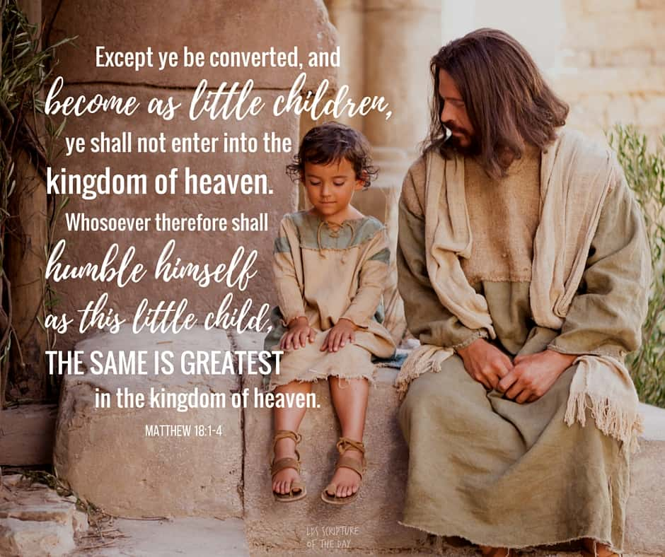
We Protect Their Innocence

THROUGH LOCAL ZONING LAWS & S.O.B. REGULATORY PERMITTING

Innocence Lost!
Helping kids deal with harmful cultural messages
“Our kids are exposed to all sorts of things through the neighborhood children — including divorce, chronic lying and alcoholism.” That’s the kind of situation more and more parents are finding themselves in, often earlier than they had anticipated.

Cultural targets
The media’s assault on our kids’ innocence has become increasingly explicit and intrusive. From TV to movies, from music to the Internet, popular culture saturates kids’ lives. The messages are sometimes blatant (such as the celebration of premarital sex) and sometimes subtle (such as disrespect for parents and other authorities). And what kids don’t get from the media, they hear at school, often by way of explicit sex-education courses.

As Michael and Diane Medved wrote in their book Saving Childhood, “The very idea of parental protectiveness has been overwhelmed by relentless pressure from a society that seems determined to expose its young to every perversion and peril in an effort to ‘prepare’ them for a harsh, dangerous future.”

A welcome guideline
But the Witts’ children don’t watch TV, and they’re home-schooled. Still, there’s no way to protect them completely from the perversion of the world.
“Kids know that sin hurts people; they’ve seen it hurt them.”
[The sin hurts] approach offers welcome guideline for parents trying to deal with the flood of information dumped on their kids too soon. While protective measures, such as carefully screening videos, are important, perhaps even more critical is teaching children how to deal with the world’s harsh realities.
How can a parent do this? Not by avoiding the culture, but by teaching God’s view of cultural messages. It sounds simple, but too many parents, even Christian parents, do not do it.

A God’s-eye view
Parents can listen to the messages kids are hearing, then teach them to step back and ask themselves, What does God think about this, and what does that mean for me? This approach establishes a strong foundation for them to stand on as they make moral choices.

But it does even more than that. It also teaches them to take a God’s-eye view of others — to understand that all people are created in God’s image and are loved by God, which is the approach the Witts took with the new neighbors.
“Children ideally need a time of innocence, a time when you are establishing in them and around them a healthy, God-governed life. They need to experience that as being the norm. They need to have friends for whom that is the norm.”
“At the same time, it’s better for a child to learn about other worldviews and lifestyles while still under close parental supervision, while we can cue them on how to respond.”

Teach kids the value of guarding their hearts from the sinful culture and also demonstrating God’s unconditional love for the perpetrators and victims of that culture. We can teach our kids not to fear the culture but to turn things around — to capture the culture for Christ.

*********************************************************
20th Century Narrow-Focus Wins 21st Century Social-Media Losses
21st Century Broad-Scope Failure

AT THE NEXUS OF GRACE & GLORY

Five Steps For Saving:

- HEARING:
- Romans 10: 17; Matthew 7: 24 - 27
- BELIEVING:
- Hebrews 11: 6; Mark 16: 15, 16
- REPENTING:
- Acts 2: 38; 17: 30; Luke 13: 3
- CONFESSING:
- Matthew 10: 32, 33; Acts 8: 36, 37
- BAPTISM:
- Romans 6: 3 – 5; Acts 8: 36 – 38

