Ashamed of the Label or the name?
by David Lee Burris
“I suppose that the church in Jerusalem would be a ‘mega-church’ to these folks. The church began with ‘about three thousand souls’ and soon ‘the number of men was about five thousand’ (Acts 2:41, 4:4). A ‘mega-church’ indeed! I can just hear the Holy Spirit endowed apostles of Jesus saying that ‘we must have these 42 committees and programs in place and operational very quickly with so many converts. We will appoint Barnabas as the Business Administrator, and Ananias and Sapphira as chairman/chairwoman (politically correct, you understand) over the various benevolent and missionary committees, and the loan funds! The former lame man, now healed and whole, can be our Minister of Worship and Music, as he has not ceased to sing and shout the praises of God since his healing (Acts 3:8-11). And our brother Agabus, the prophet, can be our representative to the churches and to the National Church Business Administrators Association to explain our 42 programs and to coordinate our work and efforts with other mega-churches!’” (Acts 11:27-30). – Church Bulletin

Influence of Modern Trends on the Church
Is new always better than old? Not always. Some modern trends have had a negative impact on the church.

By Wayne Jackson | Christian Courier

Influence is a powerful thing.
Every person both influences & is influenced by others in varying degrees. Jesus stressed the importance of godly influence when he compared his disciples to salt (Matthew 5:13).
Paul also warned of the power of bad influence when he noted that “evil companionships corrupt good morals” (1 Corinthians 15:33). The Greek word for “companionships” is homilia having to do with association. Here it denotes “bad company” (Arndt and Gingrich, 568). We tend to behave like those we run with.

The Influence of the Primitive Church
It is remarkable that the church of Jesus Christ as such was constituted in the initial centuries of its existence was a body of tremendous influence. It revolutionized the antique world. The Lord hinted of this in his prophetic parable of the leaven (Matt. 13:33).
Historians have noted that as a consequence of Christianity, many evils of the ancient world were abolished or at least curtailed (e.g., crucifixion, the brutal gladiatorial games, slavery, the abuse of women, infanticide, etc.).
Even skeptics have conceded the point. British philosopher Bertrand Russell conceded that the influence of Christianity “remains the inspiration of much that is most hopeful in our somber world” (Russell, 137).
It is not without significance, however, that when the church was exerting such a wonderful impact, it was being persecuted bitterly. Then, a strange thing happened.
In A.D. 313, Constantine issued his famous “Edict of Toleration,” which brought an end to Christian persecution. Unfortunately, it also accelerated an era of spiritual decline. Christianity even became a state religion. Ultimately, the church was “baptized” in an atmosphere that can only be described as worldliness.
Great and devastating changes were wrought that finally resulted in an egregious, fully-organized apostasy the residue of which abides to this day.

Our More Recent History
The concept of restoring pristine Christianity was revolutionary, both in Europe and in America. Courageous pioneers sought a return to the original pattern of Christ’s religion. The idea caught on, and the cause of the “ancient order” spread like a prairie fire across the frontier in the waning days of the nineteenth century.
In the late 1800s, students of the old Nashville Bible School (later named after David Lipscomb) baptized some 5,000 souls in a five-year period. In the early portion of the last century, the church was one of the fastest growing religious bodies in America.
A typical example of the influence of the church was seen in the Tabernacle Meetings conducted by N. B. Hardeman in the early 1920s. When the first meeting was held in March-April of 1922, the old Ryman Auditorium in Nashville, Tennessee was “packed and jammed” with 6,000 to 8,000 people. An estimated 2,000 to 3,000 were turned away (Hardeman’s Tabernacle Sermons, 11).
And there was no compromise of doctrine in Hardeman’s sermons! Those were glorious days for the kingdom of Christ.
But in the early decades of the previous century, something else was happening. A movement known as “modernism” was evolving. It reflected an inclination to reject the concept of propositional truth based on divine authority.
Men like Presbyterian clergyman Harry E. Fosdick (1878-1969) argued that the Bible had developed along evolutionary lines. They rejected the supernatural elements of Scripture.
This ideology became pervasive in both Catholicism and mainline Protestantism. A major component of the restoration heritage (the Disciples of Christ) was also influenced by this heresy.
More recently modernism has been succeeded by a philosophy known as “Post-modernism” This dogma, more dangerous even than modernism, is a late 20th-century theory contending there’s no such thing as real knowledge—at least in the objective sense. Rather, truth is subjectively determined by each individual.
One writer says that Postmodernism reflects a “rebellion against all aspects of the modern culture that had prevailed in the West since the late 19th century” (Dever, 30).

Postmodernism has impacted the religious community at large in a devastating fashion, and the churches of Christ have been significantly influenced by this ideology as well.

The Trendy Church
Over the past several decades there has developed a growing mentality that the church is an outdated organism. Somehow, we have lost touch with the “millennial” generation. Therefore, it’s imperative (they say) that we update the church model. We must make it more trendy.
This idea is rooted in a cultural phenomenon that may be figuratively described as “societal osmosis.” Environmental influences silently and slowly move from one realm to another. The trends of secular society to a significant degree have seeped into the religious fabric of our culture.
There is no better example of this than the current endorsement of homosexual unions in some of the historic Protestant sects. That which once was an abomination is now fashionable.
Further, the contaminated elements of “Christendom” in differing degrees ultimately trickle into the church. Not a few citizens of Christ’s kingdom are like the Israel of Samuel’s day. They lust to be like the nations [churches] round-about (1 Samuel 8:5).
Consider briefly some of the major changes that have been observable in the church over the past several decades.

A New Call for Denominational Blending
Though a few radical “voices of concern” (e.g., Carl Ketcherside and Leroy Garrett) were being raised a half-century ago, scarcely anyone would have dreamed that high-powered people in some of our major schools would be calling now for an ecumenical blending with denominationalists in the swaddling days of the new millennium.
And yet, voices as “sectarian” as anything imaginable are now frequent and unrestrained within our midst. No longer is J. D. Tant’s quip, “Brethren, we are drifting,” apropos. Many are now rushing with a head of steam towards a “Casey Jones” disaster.

Subjective Faith
We are progressively departing from a dependence on the New Testament as the authoritative source of instruction in religion and ethics towards a subjective-style, get-in-touch-with-your-feelings philosophy.
Many congregations no longer have substantial Bible classes where the Word of God is explored deeply and taught powerfully, with a solid application made to Christian living. Rather, we have “sharing” sessions wherein we “testify” of exciting events we’ve experienced in the work-place.
Even some of our Bible class literature (not a little of which has been transported from denominational publishing concerns) is filled with people-centered scenarios. “What would you do if you were in Johnny’s place?” The biblical emphasis is paper thin.

At the same time, a “new hermeneutic” has evolved by which the authority of apostolic example is questioned, the concept of necessary inference is ridiculed, the matter of the silence of the Scriptures is affirmed to be a pure fabrication.

Feminism in the Church
The influence of society’s feminists is also being felt in the church. As denominational groups ordain female “priests” and “clergy,” congregations from Connecticut to California are also opting for an expanded role for women.
Church after church is announcing that Christian ladies will be progressively employed in leadership roles. The New Testament subordination of women is viewed as a cultural oddity of the first century with little, if any, application for today.
Again, some of our [church affiliated] institutions of higher education are leading the way in this digression.

Erosion of Marriage
When Hollywood blazed the trail in serial “marriage,” many wondered if small-town America could be far behind. It wasn’t. Now, the same pattern is seen running rampant in the church.
“Single again” groups are in vogue. Experts and counselors in “marriage enrichment” skills are in great demand, while seminar directors generally are careful to throw a wide loop that avoids confrontation with the biblical law of divorce and remarriage.
Every sort of quirky notion imaginable, the design of which is to “sanctify” adulterous liaisons, has surfaced in recent years. While we must have sincere compassion for those who are victims of divorce, the compromise of biblical truth is not a solution for these heartaches.

Gimmick-based Evangelism
Just as the world of denominationalism has been gimmick-driven in recent years, so our people have not been far behind. We have explored every mechanism under the sun helpful for attracting the public’s attention.
We have offered a variety of classes and a host of public services within our neighborhoods in hopes of enticing the baby-boomers, Generation-X, and now Millennials. All the while, we largely have ignored the very thing responsible for our greatest success — the wonderful and simple proclamation of the gospel.
While some labor under the illusion that the modern world no longer wants the message of a dusty book twenty centuries old, actually, just the reverse is true. Many are starving for spiritual truth. Rich Bible teaching presented by those who are excited about the treasures of scripture is attracting the attention of many lost people.

“Contemporary” Worship
The denominational world has little interest in the teaching of the New Testament in terms of a divinely-authorized worship format. Will-worship (Colossians 2:23) for the most part has been the order of the day.

With roots that reach deep into paganism, Catholicism has been steeped in pageantry for centuries. Early Protestantism attempted a remedy. Calvin, Wesley, Spurgeon, and other notable Protestant scholars, for example, expressed strong views against the use of instrumental music in Christian worship.
Ferguson has noted that the expression A cappella (which refers to purely vocal music) literally means “in the style of the church.” His exhaustive research led to this conclusion:
The classical form of church music is unaccompanied song. To abstain from the use of the instrument is not a peculiar aberration of ’a frontier American sect"; this was easily, until comparatively recent times, the majority tradition of Christian history (Ferguson, 83).
Less than fifty years removed from Ferguson’s comment, it is not at all uncommon to hear prominent brethren arguing that instrumental music is a non-issue that certainly ought not to be treated as a test of Christian fellowship.
“There should be room in the Christian fellowship for those who differ on whether instrumental music is used in worship” (Osburn, 90).
It is almost certain that conditions are developing among churches of Christ that eventually will accommodate large-scale innovations in congregational worship.
Even now, a number of sizable churches following the lead of denominational groups (Veith, 4-5) are staggering their services, providing a “traditional” worship format for the older generation (dare we say, “fogies”?). Then also a jazzed up service is arranged for those who are more contemporary.
Too, it is a sad commentary on our attitude toward the hours of sacred worship that our dress has degenerated to casual, not to mention sloppy. Sandals and shorts are observable not infrequently in some places.
What has happened to our sense of solemnity of occasion? What impression do we convey to community visitors?

Conclusion
In his letter to the saints in Rome, Paul instructed the brethren to “be not fashioned according to the world” (Romans 12:2). The present imperative form of the verb means, “stop being fashioned [conformed — KJV]!” The principle involved in this admonition is broad in its application. Barclay attempts to catch the spirit of it.
“Don’t try to match your life to all the fashions of this world; don’t be like the chameleon which takes its color from its surroundings; don’t go with the world; don’t let the world decide what you are going to be like” (170).
Let us summon the courage to make the appropriate applications, yielding to truth and common sense, rather than fickle trends of an unspiritual society.

Change Agents in the Church

We have some in the body of Christ who are trying to affect change in the church. The winds of change are blowing, brethren, and we must be warned, lest we find ourselves being pulled under by the swirling waters of apostasy all around us.
The Name of the Church. Some seem to think the name “church of Christ” has such a stigma to it that they are undergoing a name change. Signs that used to read, “The church of Christ meets here” are changed to say, “Christians meet here.” Some churches that have been recognized as the church of Christ for many years are dropping the name of Christ and are just called the church at ___________. Paul was not ashamed to say, “churches of Christ” in Romans 16:16. Why would we, as the Lord’s people, not want to be associated with Christ. Christ built the church (Matt. 16:18) and purchased it with his own blood (Acts 20:28). Therefore, the church belongs to Christ. Why not just call the church what it really is — the church of Christ? However, if a group of people are not going to respect Christ’s authority in all things, they would do us a favor if they would change their name or put up a message, “This isn’t the church of Christ.”

Preaching on How To Establish and Apply Bible Authority, Bible Baptism, The One True Church, Why We Sing and Don’t Play are rarely heard now. Sermons are being preached that could be preached without offense in any denomination in town. When such preaching is allowed to continue, it will not be long until you will see no difference in that church and the denominations around them. Nothing will weaken the church more than weak preaching.
What We Call Things. Our basic motto has been to “call Bible things by Bible names.” Many are getting away from that. A preacher told me that he refused to be bound by “creedal phrases of the restoration movement,” as he called it. Churches aren’t distinctive as they once were, as they use denominational terms to express themselves. This reminds me of when the children of Israel “spake half in the speech of Ashdod, and could not speak in the Jews’ language” (Neh. 13:24).
The Role Of Women. The woman’s role in the church is being expanded beyond the scope of Bible authority. Women are being included in the decision-making business meetings and are even being put in positions of church leadership. When we point out passages like 1 Timothy 2:11-12 and talk about God’s place for women, we are told we are demeaning and degrading women.
Attitude Toward False Teachers. I see a change in the attitude of many toward who a false teacher is and how to deal with false teachers. False teachers are being re-defined from one who teaches something contrary to sound doctrine to one who has impure motives and is of corrupt character. We’re encouraged to receive men who teach things the Bible does not teach as they are honest and sincere, when Scriptures teach us otherwise (Romans 16:17; 2 John 9-11). When we identify a man by name, document his false teaching, and expose it in the light of truth, we are accused of biting and devouring.
Fellowship. Fellowship is being extended to those who teach false doctrine and practice immorality. Brethren are receiving into their fellowship individuals out of denominations without them being “baptized into the one body” (1 Corinthians 12:13). When brethren think there are Christians in denominations and extend the hand of fellowship to those in denominationalism, they will soon take on characteristics of the denominations around them.
The Way We Look At the Bible. Instead of appealing to direct statement or command, apostolic example, and necessary inference to establish scriptural authority for a thing as the apostles did in Acts Chapter 15, we’re hearing instead, “purpose, principle, precedent,” as a cry is made for a new way of interpreting Scriptures.
- John Isaac Edwards
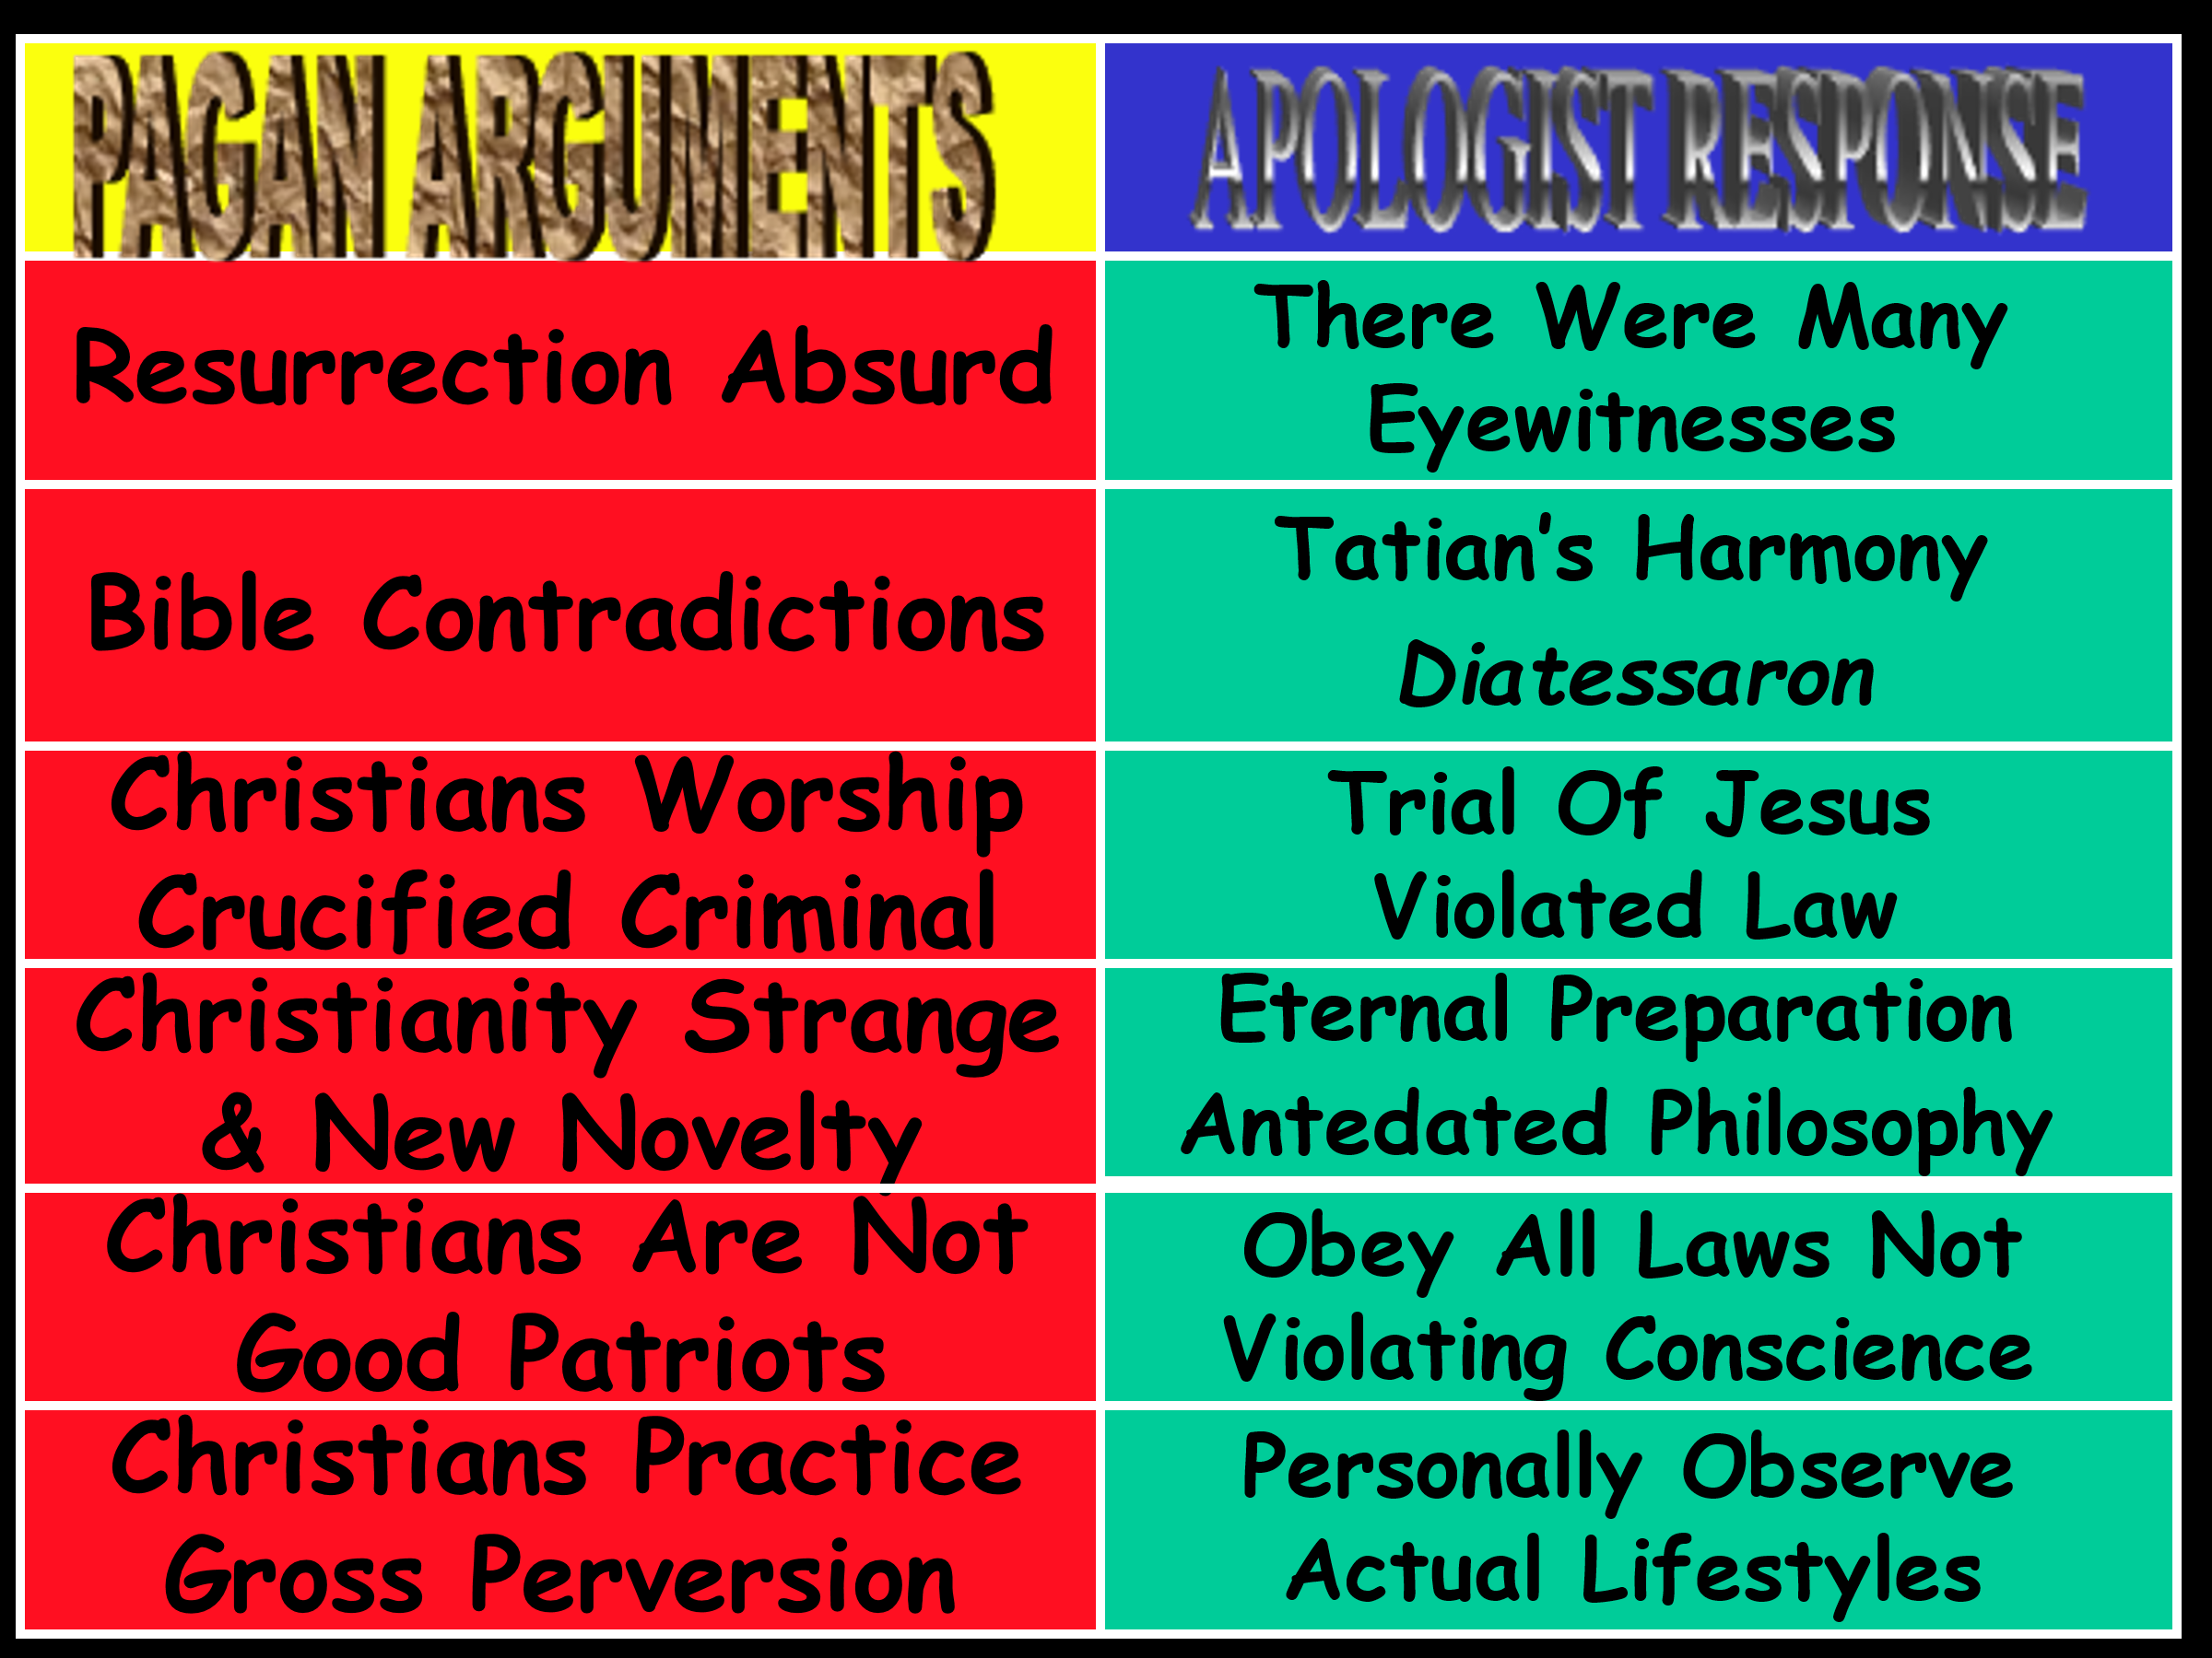
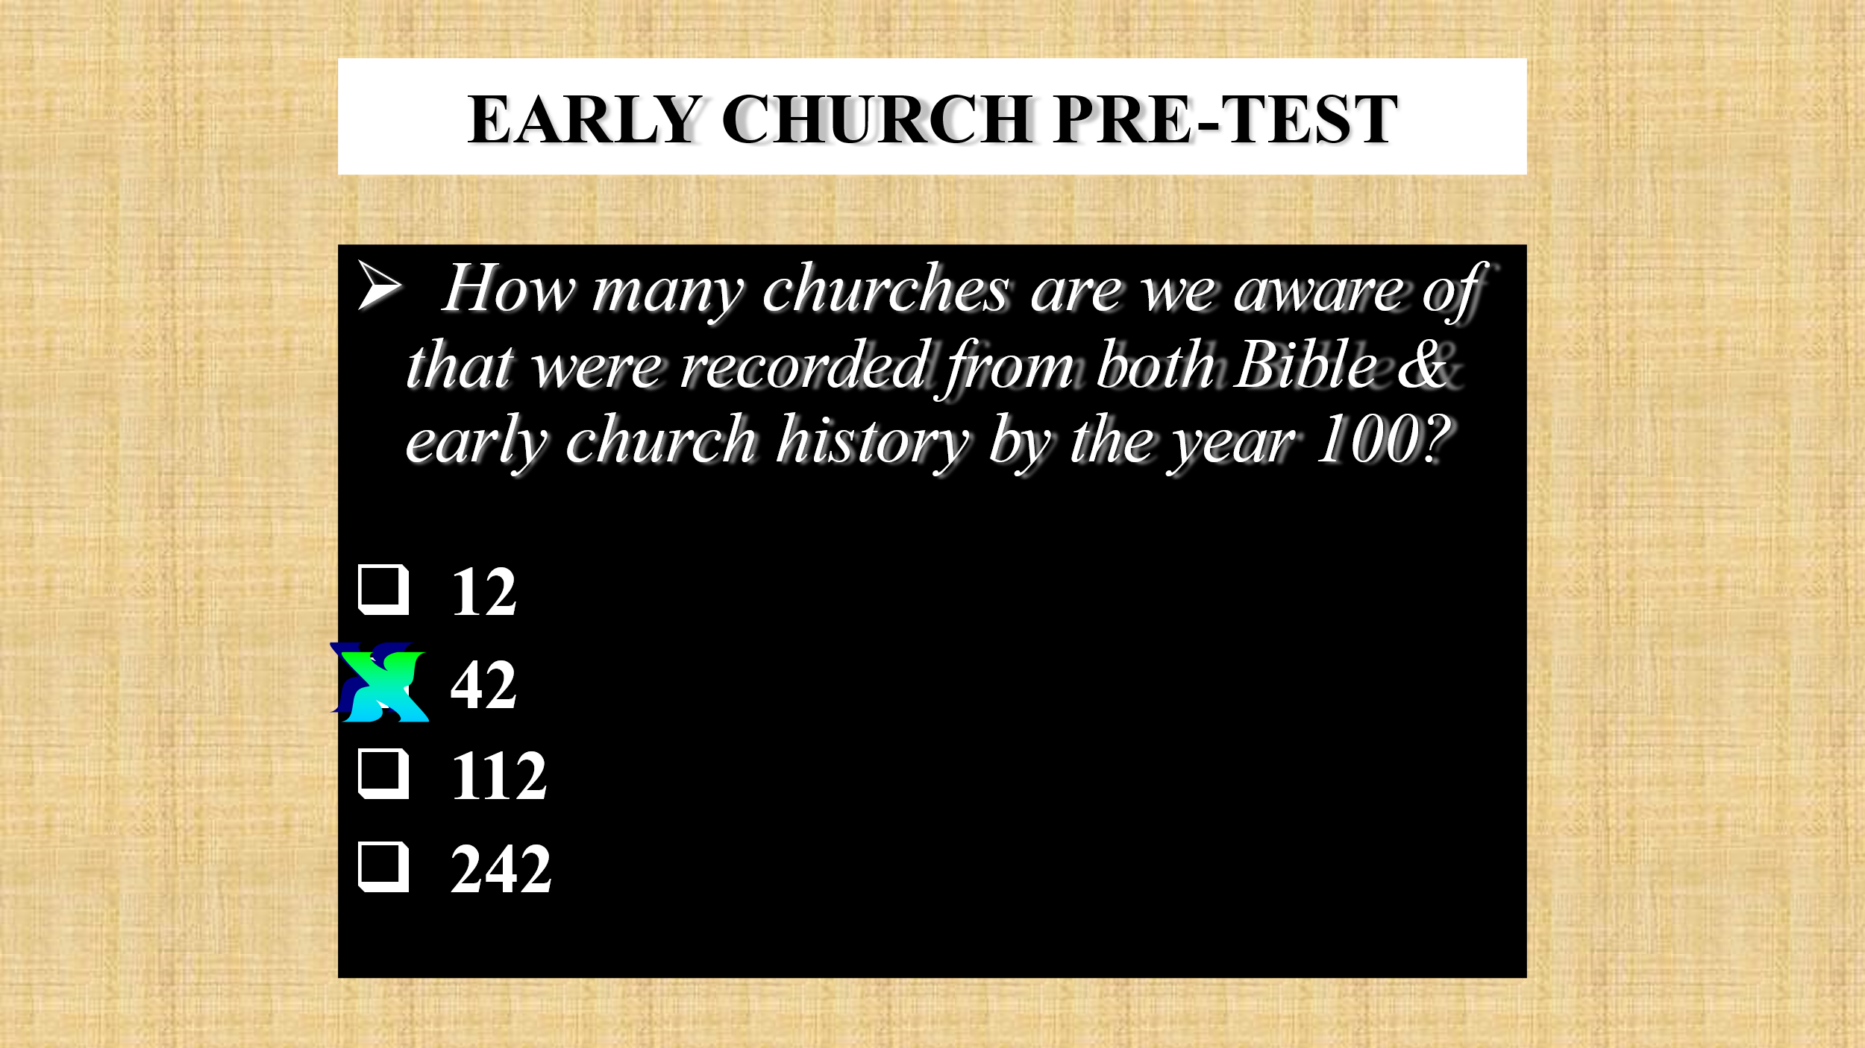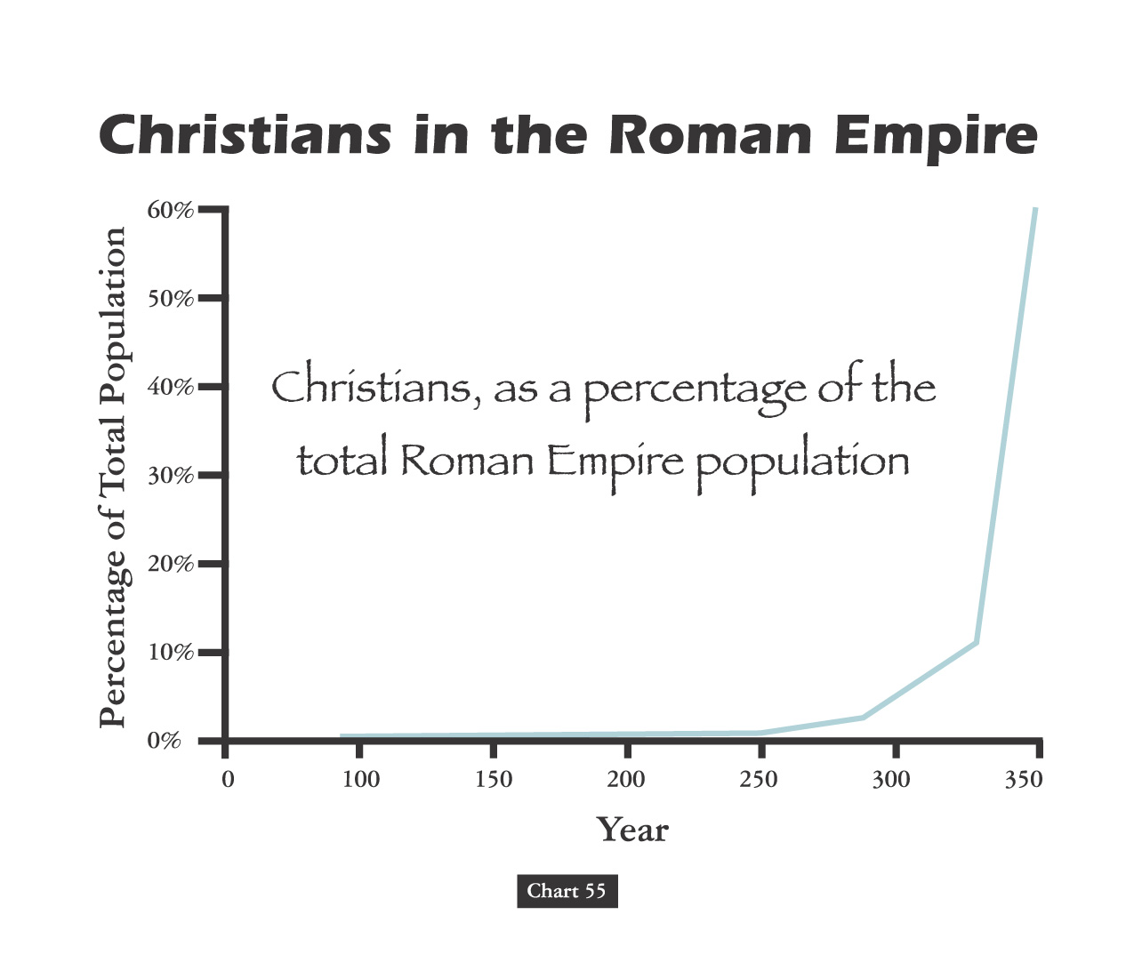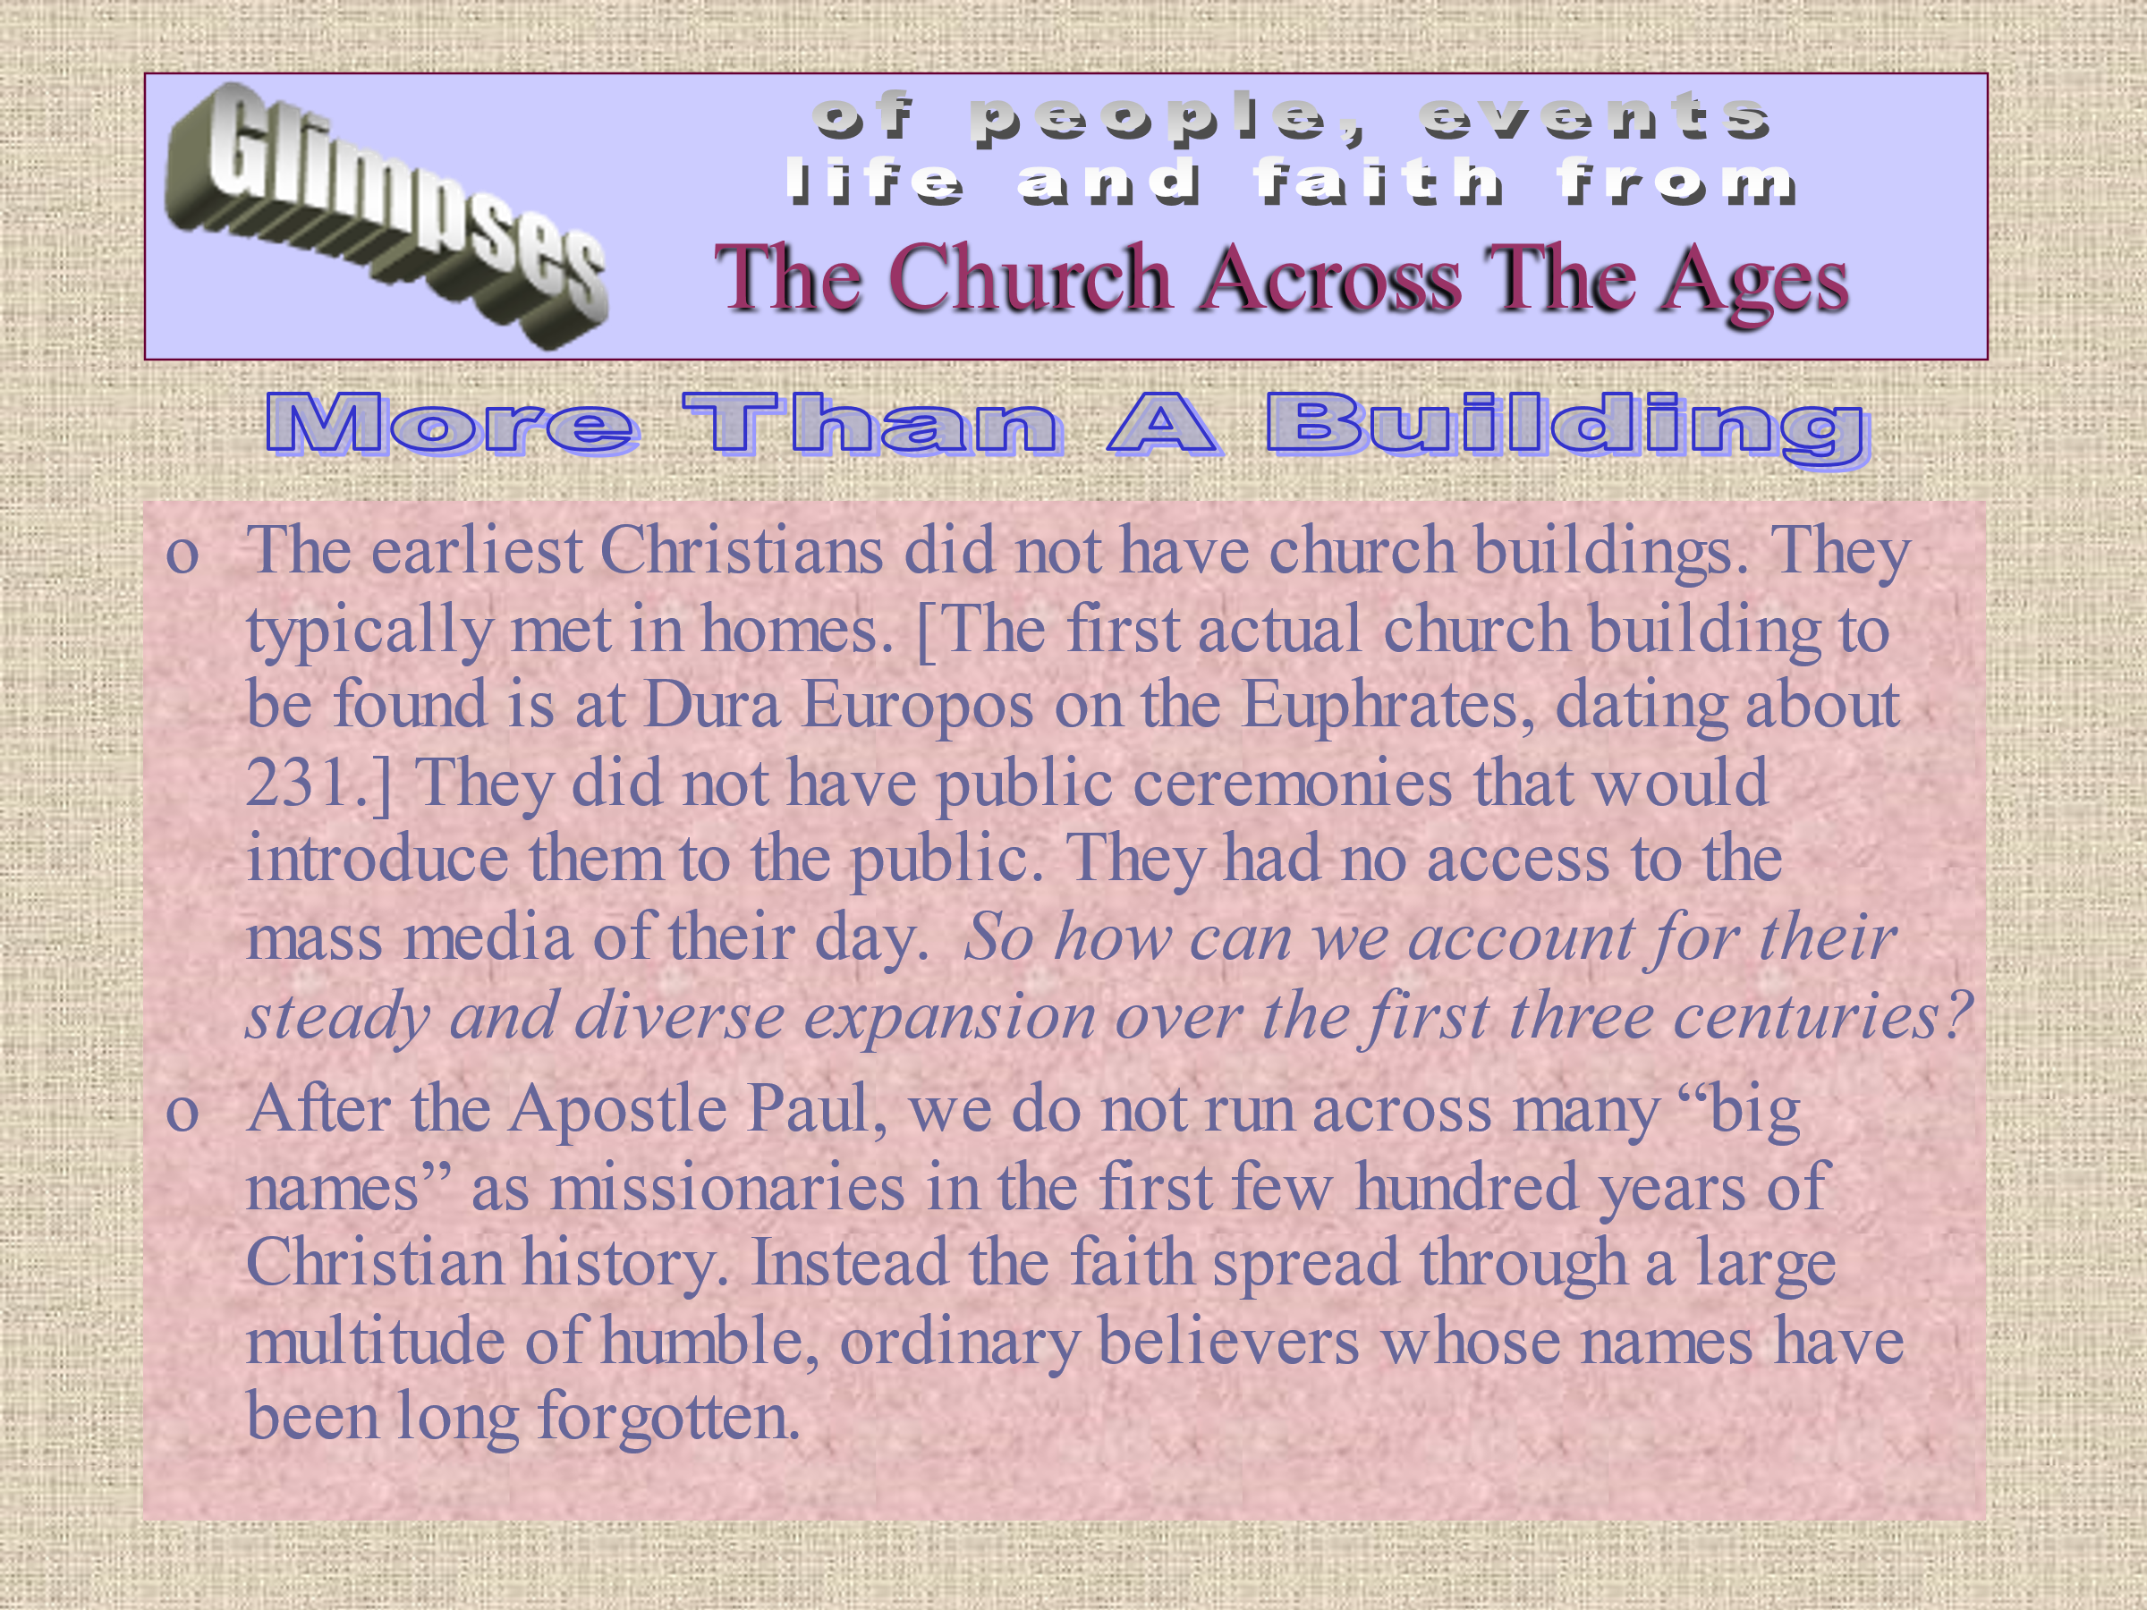
Reclaiming Our Identity: WE KNOW WHOSE WE ARE!
“For whoever is ashamed of Me and My words, of him will the Son of Man be ashamed when He comes in His glory, and the glory of the Father and of the holy angels” (Luke 9:26). The world can be an intimidating place. It must have been intimidating to those in the first century who endured persecution for the name of Jesus Christ. Peter remarked, “If you are reviled for the name of Christ, you are blessed, because the Spirit of glory and of God rests upon you. By no means let any of you suffer as a murderer, or thief, or evildoer, or a troublesome meddler; but if anyone suffers as a Christian, let him not feel ashamed, but in that name let him glorify God” (1 Pet 4:14-16). The name of Christ is so close to the heart of any devoted Christian that he will be unwilling ever to deny or shame it. For some years many people within churches of Christ have been going through an identity crisis. Some people have reacted negatively to what they perceived to be undesirable and have sought to create a new image for the church. They did not want to be identified with the church or the beliefs of the church. In some cases they were right to desire a change in our attitudes and our behavior. Some were arrogant in their overzealous attempts to bring people to the truth. Some, frankly, have portrayed a “better-than-thou” attitude toward those with whom they disagreed. Some, like the Pharisees, took on a view that only their brothers were their neighbors. Others were out of balance in their hellfire and brimstone preaching and lacked an understanding of grace. Some were too quick to condemn others over opinions and man-made laws. These attitude problems, pride and ambition, led to petty divisions and broken congregations. It became fashionable, however, to blame so many of our weaknesses on our hermeneutic and theology. They accused us of widespread Phariseeism and narrow-mindedness. Young preachers began to mock at those who came before us and anything that smacked of tradition. Quoting Scripture was replaced with a “pop-psychology” theology, and meeting “felt” needs became more important than a “thus saith the Lord.”
Our sermons changed from declaring first principles to essays on self-esteem and stress. We were not happy with who we were, so it became necessary – at least in the minds of some – to reinvent ourselves to be more appealing to the world. We began thinking that a new name would allow us to create a new image for our communities. We began with a more inclusive posture, unwilling to make judgments on the pious un-immersed. We relegated the controversial to opinion, taking the view that we could not be certain of Bible teachings. We did not want to be seen as people who made narrow judgments. Ultimately, we decided that we were not going to make hard and fast decisions on who is and who is not a Christian. We knew spiritual people among other groups, and we didn’t want to condemn them or be embarrassed in front of them. We wanted to join them in order to have the unity that Jesus prayed for.
We became ashamed of what we were and became like the spiritual nations around us. We became ashamed not of our abuses but of our strengths. We shed the things that were most valuable to our identity as children of God in order to accommodate a likeness to the world.

Ashamed of the Name “Church of Christ”
Among churches of Christ, the name “church of Christ” has come upon hard times. Some today are now rejecting the use of that name, claiming that it is sectarian. Others are rejecting the name because they do not want to be associated with the undesirable behavior that some members of the “church of Christ” have manifested. The old statement that “those people believe you have to be a member of the church of Christ to be saved” has led some to be ashamed of anything that uses the phrase, “church of Christ.”
Consequently, a new generation of churches of Christ has adopted some alternative names. Some now go by “Community Church,” putting the phrase “a church of Christ” on the sign in small letters.
Will these same people one day be ashamed of the phrase “family of God” when they suppose that there is too much offensive baggage associated with that name? Would they change their personal name if some member of the family should disgrace it?
The Community Church. Perhaps the idea is that the church is to be identified with the community. This has a fine marketing appeal, but where is the Lord glorified? Does a community church belong to Jesus or the community? One must ask how the designations “community church” or “family of God” are less sectarian than other names.
Sometimes those who are ready to trash a tradition merely begin a new one. Perhaps they should consider the consequences of their new tradition a generation or two from now. The words “church of Christ” are not a formal name so much as they are a description of who we are.
The Scriptures do not give any title to the church, but no one should doubt that the church uniquely belongs to Jesus. Jesus is the builder of the church (Matthew 16:18); He is the One who purchased it with His blood (Acts 20:28); He is the one and only foundation of the church (1 Corinthians 3:11); He is the head of the church (Ephesians 1:22-23); and He is the one and only Savior of the body (5:23). When Jesus spoke of the church, He called it “my church” (Matthew 16:18); and when Paul describes the congregations, he calls them “churches of Christ” (Romans 16:16).
Paul describes the name of Jesus as that which is above every name (Ephesians 1:21); and it is the name at which every knee will bow and every tongue will confess to the glory of the Father (Philippians 2:9-10). Whatever we do in word or deed, we are to do in the name of the Lord Jesus (Colossians 3:17); and His name is to be glorified in us (2 Thessalonians 1:12). The name we name is more excellent than the name of the angels (Hebrews 1:4). The name of Jesus Christ, by which we are called, is a fair name (James 2:7); it is the name in which we are to glorify God (1 Peter 4:14-16). We must always hold fast to that name (Revelation 2:13), fear His name (11:18), and never deny His name (3:8).
Should the church wear the name of Jesus Christ? Yes. Should the church denominate that name? No. The phrase “church of Christ” ought always to be a description of who we are and whose we are. Those who are critical of our use of that name, saying we have somehow denominated it ought to be careful that they are not guilty of the same error with other descriptions.
Ashamed of the Teaching. It is surprising indeed that some want to be recognized as Christians but are unwilling to be constrained by His teachings. It is as if they think they ought to be more righteous than Jesus, or they need to update His teachings so that they will be more in tune with the times. To be ashamed of Jesus’ teachings is as if to be ashamed of Him. One cannot separate the message from the person of Christ. Indeed, the message of Jesus is a part of His very identity as the Son of God. The drive to grow churches has led some to a point of view that they are willing to do whatever it takes to enlarge their numbers. The desire to grow is noble; any faithful Christian wants the Lord’s body to increase & will work tirelessly to see that it does.
Growth, however, is not the same thing as making disciples. Swelling numbers is not a guarantee of growing disciples. It takes more than filling a pew to be a disciple. Some have suggested that the only healthy churches are the ones that are growing numerically. They further imply that if a church is not growing, it needs to change.
In Revelation, John remarkably never mentions numerical growth when he assesses the spirituality of the seven churches of Asia. He says much, however, about their spiritual growth, their works, their love, and their faithfulness to the Lord and the truth. The healthy churches were those remaining faithful during times of persecution, and those who remained free from immorality.
Having the largest congregation in the world is of little good if the devil runs it; and he will try! One of the ways he enters churches is by the promise of numbers. The devil tempted Jesus with quick growth if Jesus would jump off the pinnacle of the temple. Jesus declined and pointed to a deeper spiritual truth.
The devil tempted Jesus with the world at His feet if Jesus would merely bow down to him. Jesus declined and pointed to the one true God. We must be careful to assess the cost of church growth that is too quick and too easy. The cost may be higher than we imagined. The Bible doesn’t mandate “church growth”; it mandates gospel preaching and making disciples. The real disciples of Jesus are those who abide in the word of God (John 8:31), who bear fruit (10:8), who love others as Christ does (13:35), and who remain faithful to Him (6:63-66). It is better to make one true disciple than add 100 to a congregation run by Satan.
This is not to approve laziness and a lack of evangelistic fervor; it is to point out that numbers are not necessarily the proof of God’s blessing. Jeremiah preached 40 years with little success. God did not honor him for his numerical success but for his faithfulness.
We might be numerically successful with a watered-down gospel, but a watered-down gospel does not make disciples who will die for the faith. If we compromise our message to get large numbers, we will have to compromise even more to keep those numbers. In the end our faith will become worldly, insipid, irrelevant and ineffectual.
Jesus did not compromise or waver on the things that mattered. He held firm to the hard line. The Lord meant what He taught. He did not take back what He said when the tide of public opinion turned against Him. Our Savior said, “If anyone comes to Me, and does not hate his own father and mother and wife and children and brothers and sisters, yes, and even his own life, he cannot be My disciple. Whoever does not carry his own cross and come after Me cannot be My disciple” (Luke 14:26-27).
At one point Jesus taught His disciples a very difficult thing. They asked, “[W]ho can listen to it?” (John 6:61) Jesus was conscious of their grumbling and asked them, “Does this cause you to stumble?” Jesus knew that some of the people there simply did not believe Him.
To be ashamed of what Jesus teaches is to cut yourself off from hope of life. As a result of this many of His disciples withdrew, and were not walking with Him anymore. Jesus said therefore to the twelve, “You do not want to go away also, do you?” Simon Peter answered Him, “Lord, to whom shall we go? You have words of eternal life. And we have believed and have come to know that You are the Holy One of God” (vv. 66-69). There simply is no substitute for the gospel message; only it has the words of eternal life. To be ashamed of the words of Jesus is to cut oneself off from the blessings of the Lord.
When the people left, Jesus did not trip all over Himself trying to get them to come back. He did not take back His message in order to get or keep the numbers. He did not apologize. He did not reduce His standards in order to give more people opportunity. He let them go.
The temptation here is to think that Jesus’ behavior is not very compassionate. Does He not love them? Is He not the Good Shepherd who leaves the 99 to recover the one lost sheep? Yes, He is all these things. Jesus stayed silent with these fair-weather followers because He knew the stubbornness and the weakness of their hearts. He had given a demanding challenge to them that they were unwilling to accept. If there had been any other discussion, it would have meant that Jesus would have had to compromise. He was unwilling to do that and really had nothing else to say to them. If He had given in on this point to keep them, what else would He have had to do to keep them? God’s standards cannot be bought at the price of popularity. The cost of discipleship is a cross.
Fundamentally their point of view was that they had come to Jesus to get something from him; when it came to suffering and giving to him they quit.
When Solomon urged us to buy the truth, it was because he knew that truth costs something.
Sanders, Phil. Adrift: Postmodernism in the Church. Gospel Advocate Company. Kindle Edition.
AT THE NEXUS OF GRACE & GLORY

Five Steps For Saving:

- HEARING:
- Romans 10: 17; Matthew 7: 24 - 27
- BELIEVING:
- Hebrews 11: 6; Mark 16: 15, 16
- REPENTING:
- Acts 2: 38; 17: 30; Luke 13: 3
- CONFESSING:
- Matthew 10: 32, 33; Acts 8: 36, 37
- BAPTISM:
- Romans 6: 3 – 5; Acts 8: 36 – 38

