Blasphemy Is Nothing To Laugh At!

by David Lee Burris
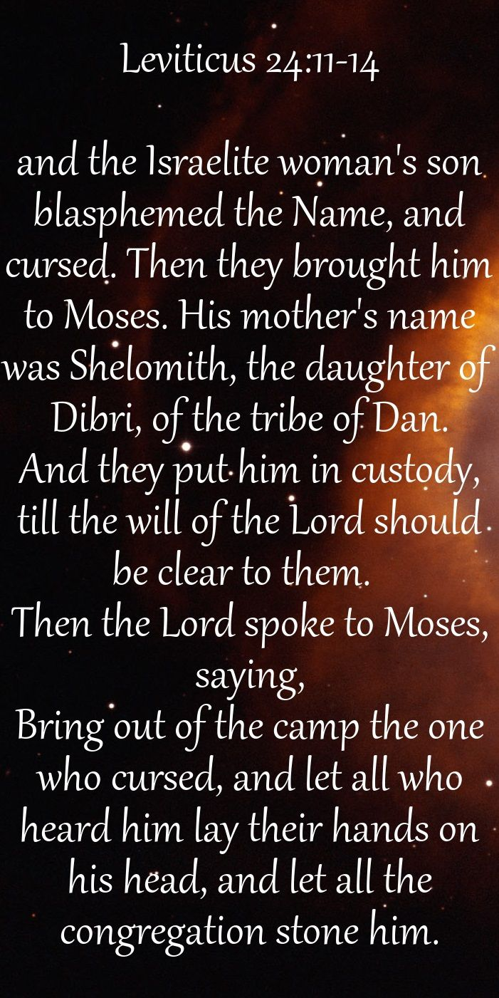
Blasphemy
1. Christ assailed with. Mt 10:25; Lu 22:64,65;1 Pe 4:14.
2. Charged upon Christ. Mt 9:2,3; 26:64, 65; Jn 10:33,36.
3. Charged upon saints. Acts 6:11, 13.
4. Proceeds from the heart. Matthew 15:19.
5. Forbidden. Exodus 20:7; Colossians 3:8.
6. The wicked addicted to. Ps 74:18; Isa 52:5; 2 Ti 3:2; Revelation 18:11, 21.
7. Idolatry counted as. Isaiah 65:7; Ezekiel 20:27,28.
8. Hypocrisy counted as. Revelation 2:9.
9. Saints grieved to hear. Psalm 44:15,16; 74:10,18,22.
10. Gives no occasion for. 2 Samuel 12:14; 1 Timothy 6:1
11. Against the Holy Spirit, unpardonable. Mt 12:31, 32.
12. Connected with folly and pride. 2 Ki 19:22; Ps 74:18.
13. Punishment of. Le 24:16; Isa 65:7; Eze 20:27–33.
14. Exemplified
a. The Danite. Leviticus 24:11.
b. Sennacherib. 2 Kings 19:4, 10, 22.
c. The Jews. Luke 22:65.
d. Hymenaeus. 1 Timothy 1:20.

Blasphemy A verbal insult uttered intentionally and malevolently against God, revealing the offender’s absolute contempt for Him.
Biblical Relevance
Expressed in various forms in the Bible, blasphemy includes flagrant actions and disdain for God’s Word, His promises, and His people. Scripture bears consistent witness to the severity of the offense. In the Old Testament, a member of the Israelite community would be put to death for it; in the New Testament, condemnation is said to await one who blasphemes the Spirit.
In the Old Testament
Using and Misusing the Name of God
When God first appears to Moses in the burning bush, He emphasizes the sacredness of His name (שֵׁם, shem), Yahweh (made of four Hebrew consonants, known as the Tetragrammaton, יהוה, yhwh), which reveals His person and character as the covenant-keeping, redeeming God (Exod 3:13–16; 6:3). In the exodus story, God performs mighty deeds for the sake of His name (Exod 9:16), a concept reiterated in numerous Old Testament passages (Psa 25:11; Isa 43:25; 48:11). The “name of Yahweh” (שֵׁם־יְהוָה֙, shem-yehwah) carries profound significance, referring “to His full being and power” (HALOT, 1550). To assail God’s name is to attack Him personally and directly.
Speaking both to Moses and people of Israel, God strictly prohibits the misuse of His name: “You shall not take the name of the Lord (יהוה, yhwh) your God in vain, for the Lord (יהוה, yhwh) will not hold him guiltless who takes his name in vain” (Exod 20:7 ESV). The Hebrew term “vain” (שָׁוְא, shaw') refers to what is empty or purposeless; it can also mean something false or deceptive, in such contexts as prophecy (Ezek 13:3–7), worship (Isa 1:13), and speech (Deut 5:20). A breach of the first two commandments naturally leads to a violation of the third (Exod 20:7).
The “misuse” of Yahweh’s name includes taking oaths falsely in His name (Lev 19:12), profaning His name (Lev 19:12), cursing His name (Exod 22:28), and falsely representing Him (Jer 14:14).

Since peoples of the ancient Near East believed that words had special powers to affect people (e.g., to pronounce a curse), any use of Yahweh’s name in this way would also be forbidden (NIDOTTE, 3:340).
Leviticus 24:10–23

The central Old Testament text on blasphemy is Lev 24:10–23. The offender, the son of an Israelite woman and an Egyptian man, utters the Name (שֵׁם, shem) “cursing blasphemously” literally, “blasphemed (נָקַב, naqav) the Name (שֵׁם, shem) and cursed (קָלַל, qalal)” (Lev 24:11 ESV)—clearly violating the third commandment (Exod 20:7). Moses and the people wait for a clear word from Yahweh (Lev 24:12), who set down this ruling: “Whoever curses (יְקַלֵּל, yqallel) his God shall bear his sin. Whoever blasphemes (בוְנֹקֵ֤, vwnoqe) the name (שֵׁם, shem) of the Lord (יהוה, yhwh) shall surely be put to death” (Lev 24:15–16 ESV).
As reflected in the LXX, the typical Jewish reading of Lev 24:16 (also 24:11) is to translate נָקַב (naqav) not as “blaspheme” but “name” (ὀνομάζω, onomazō). This means that the man was guilty simply for “naming” or “uttering” the name of Yahweh (Weingreen, “Case of the Blasphemer,” 118–19). Devout Jews will not even mention the Tetragrammaton (יהוה, yhwh) in order to avoid blasphemy.
Old Testament Word Group

The Old Testament uses a number of Hebrew terms for blasphemy and related concepts. In three passages (Job 3:8; Prov 11:26; Lev 24:11, 16) the term נָקַב (naqav) means “to curse” or “to blaspheme.” Closely related, קָלַל (qalal) means “to curse, treat or esteem lightly, make contemptible, belittle” even “to deprive someone of their stature and importance” (TDOT, 13:39). In Leviticus 24:10–23 the word appears four times in close connection with נָקַב (naqav). In 1 Samuel 3:13 Eli’s sons were “blaspheming (קָלַל, qalal) God” by their impious acts, which led to their deaths (1 Sam 4:11). A third term, גָּדַף (gadaph), means “to revile, blaspheme, insult” (2 Kgs 19:6, 22; Isa 37:6, 23). Even defiant actions can be considered blasphemy (Num 15:30 NAS). This concept also appears in Ezek 20:27, where Yahweh censures the Israelites, whose actions of persistent idolatry amounted to blasphemy.
The term חָרַף (charaph, “to taunt, reproach”) is usually associated with pagans denying God’s greatness and power while extolling their own (2 Kgs 19:22). Goliath taunts the Israelites and their God (1 Sam 17:1–58), and the psalmist complains of the appalling way Gentile nations reproach (חָרַף, charaph) God’s name (Pss 69:9; 74:10, 18; 79:12; 89:51).
When the Israelites, by their unbelief, display lack of reverence for the Lord and rebel against Him, the word נָאַץ (na'ats, “to despise, to treat disrespectfully, blaspheme”) frequently occurs (Num 14:11; 14:23; 16:30; Deut 31:20). Elsewhere, the psalmist complains of the enemy’s renunciation of God (Pss 10:3, 13; 107:11), and the prophets indict the wayward Israelites for having despised (נָאַץ, na'ats) the Lord (Isa 5:24; Jer 23:17; Ezek 35:12).
Usually Old Testament writers use בָּרַך (barakh) to express the concept of “blessing” (e.g., Gen 12:3). However, in a handful of passages, בָּרַך (barakh) carries the opposite intent, “to curse.” For literary effect, the book of Job uses בָּרַך (barakh) antiphrastically (or euphemistically) (Job 1:11; see also Job 1:5; 2:5; 2:9). In another instance, a plot against Naboth includes the accusation of his cursing (בָּרַך, barakh) God (1 Kgs 21:10, 13). The psalmist complains that a greedy man curses (barakh) the Lord (Psa 10:3).
In Leviticus 18:1–22:33, God repeatedly warns the Israelite priests not to “profane” (חָלַל, chalal) God’s name by offering children to Molech (Lev 18:21; 20:3), falsely swearing by God’s name (Lev 19:12), violating priestly standards (Lev 21:6), or eating holy things while ceremonially unclean (Lev 22:2). Ezekiel reiterates the way by which God’s sanctuary (Ezek 44:7) and Sabbaths (Ezek 20:24) have been profaned by Israelites of his day (see also Ezek 20:9; 20:13–14; 20:21–22, 20:39; 36:20–23; 39:7). Jeremiah refers to oppressing people who are in slavery, which is tantamount to profaning (חָלַל, chalal) God’s name (Jer 34:16; see also Amos 2:7). These social injustices bring dishonor to Him.
Finally, some 46 Old Testament verses employ כָּעַס (ka'as) for incidents where God’s people provoke Him (or where an act of provocation occurs), and in every case it has to do with violating the first and second commandments. For example, Isaiah declares God’s message of complaint: “I have spread out My hands all day long to a rebellious people, who walk in the way which is not good, following their own thoughts, a people who continually provoke (הַמַּכְעִיסִים, hammakh'isiym) Me to My face, offering sacrifices in gardens and burning incense on bricks” (Isa 65:2–3 NAS).
In the New Testament

The New Testament elevates the offense of blasphemy to an even higher level. In light of the New Testament’s greater revelation, specific members of the Trinity are singled out as the objects of blasphemy. The many instances where the Lord suffers vilification and reproach serve as the most appalling examples of blasphemy, and in one instance, blasphemy leads to eternal condemnation. God’s people can also experience slander for their identification with the Lord.
New Testament Word Group
The βλασφημέω (blasphēmeō) word group appears 56 times in the New Testament. Such English verbs as “curse, revile, slander, insult, malign, defame” serve as equivalents. In most instances, nonbelievers pronounce blasphemy against God the Father (Rev 16:9, 11, 21) and His name (Rom 2:24), the Son of God (Mark 15:29; Luke 22:63–65), and the Holy Spirit (Matt 12:31; Mark 3:28–29; Luke 12:10).
Religious leaders frequently accuse Jesus of blasphemy (Matt 9:3) because He claims for Himself the attributes, rights, and prerogatives of God (John 10:33–36), including the authority to forgive sins (Mark 2:7). After His final confession (Matt 26:64), they charge Him with blasphemy and sentence Him to death on that basis (Matt 26:65–66; John 19:7). Ironically, they are the blasphemers against Jesus.
Paul later recognizes this (1 Tim 1:13) and admits that one of his primary objectives in his pre-conversion days was to induce believers “to blaspheme” (Acts 26:11), that is, to renounce their faith. In Acts, the Jews falsely accuse Stephen of blasphemy (Acts 6:11) but commit blasphemy themselves for rejecting the gospel (Acts 13:45; 18:6). Other objects of blasphemy (or slander) include the Word of God (Titus 2:5), the truth (2 Pet 2:2), and doctrine (1 Tim 6:1). The last days will give rise to “blasphemers” (2 Tim 3:2) and to false teachers noted for blasphemy (2 Pet 2:10–12; Jude 8, 10).
God’s people can be slandered (or maligned) for their testimony (1 Pet 4:4). Believers need to lead morally upright lives so as not to provide occasion for slander on the part of nonbelievers, which would bring a poor reflection on Christ (Rom 14:16; 1 Cor 10:30; Titus 2:5; 1 Tim 6:1). Blasphemy springs from the sinful human heart (Matt 15:19; Mark 7:21), but believers in Christ, as redeemed people, must lay it aside (Eph 4:31; Col 3:8; Titus 3:2).
Other terms with similar connotations as βλασφημέω (blasphēmeō) include:
• ὀνειδίζω (oneidizō), “to revile, reproach,” (Matt 27:44; Mark 15:32; Rom 15:3; see LXX Psa 68:10)
• λοιδορέω (loidoreō) or ἀντιλοιδορέω (antiloidoreō), “to hurl abuse at” or “to hurl abuse in return” (1 Pet 2:23; see LXX Num 20:13)
• ὑβρίζω (hybrizō), “to mistreat” (Luke 18:32)
• ἐξουδενέω (exoudeneō), “to despise, treat with contempt” (Mark 9:12)
• ἐξουθενέω (exoutheneō), “to treat with contempt” (Luke 23:11)
• ἐμπαίζω (empaizō), “to ridicule, mock, make fun of,” which usually refers to the mocking of Jesus at His trial and crucifixion (Matt 20:19; Matt 27:29, 31, 41; Mark 15:31; Luke 22:63; 23:11, 36)
• ἐκμυκτηρίζω (ekmyktērizō), “to sneer at, ridicule” (Luke 16:14; 23:35; compare LXX Psa 21:8)
• κακολογέω (kakologeō), “to speak evil against” (Mark 9:39; Acts 19:9)
• ἐνυβρίζω (enybrizō), “to insult,” which is directed toward the “Spirit of grace” (Heb 10:29)
All of these terms describe verbal and other assaults against Jesus, except for Hebrews 10:29.

I. What is blasphemy?
A. A transliteration of a Greek word, blasphemia
1. It is a compound word: hurt and speech
B. It means to speak evil of someone or to slander someone
1. Contained in it is the idea that a third party is involved
2. It is one person telling other people how bad another person is
3. Example of what the Pharisees did - Matthew 12:23-24
C. It is not a bad thought. It is an active attempt to destroy another person
D. Generally reserved for slandering deity - Leviticus 24:11,15
1. It doesn’t have to be curse words, anything that lowers God’s stature in the eyes of others is blasphemy
2. Example of the golden calf- Nehemiah 9:18
a. Attributing God’s great power to a man-made image
3. Replacing God with idols - Ezekiel 20:27-28
E. Some exceptions to blasphemy being only about God
1. Moses was blasphemed - Acts 6:11
2. Idol worshipers saw statements against their gods as blasphemy - Acts 19:37

II. The Character of the Blasphemer
A. Envious of the other person - Acts 13:45
B. Defiant - Numbers 15:30-31
1. Every act of defiance is not blasphemy
2. The motivation behind blasphemy is purposeful defiance
3. Not something accidentally done. It is not inappropriate statements said while drunk, high on drugs, on in a fit of anger
C. Repeated Behavior
1. Example of the scribes and Pharisees
a. A rumor started by the scribes - Mark 3:20-22; Matthew 9:34; 10:25
b. Continued to be spread - Matthew 12:22-24; Luke 11:14-15
c. Continued despite repeatedly refuted and warned that it could cost them their souls – these people didn’t care
d. No evidence would change their opinion. They weren’t interested in the truth
e. They hated Jesus so much they would say anything to destroy him
2. Assyria’s defiance of God - Isaiah 52:5
3. It is the nature of a blasphemer to remain in his sin
D. Stubborn
1. Korah’s rebellion - Numbers 16:3
a. Korah may have saw this as rebelling against Moses, but he was rebelling against God too. God is the one who put Moses in his position.
b. Korah is Levite, he should have remembered what happened to Nadab and Abihu (Leviticus 10).
c. Korah should have remembered what happened to Miriam not that long ago - Numbers 12:1-10

d. There was repeated warnings - Numbers 16:5-7
e. There were plenty of opportunities for Korah and his followers to back out - Numbers 16:23-34
E. Pride - Isaiah 37:23
1. Blasphemy reflects a severe defect in character
F. They do not easily change
1. When God was pouring his wrath on Rome - Revelation 16:9, 11
2. Paul was a rare exception to this rule - I Timothy 1:12-13

III. Blasphemy is not accidental.
1. Blasphemy reflects a person whose character is against God – stubborn, defiant, and unrepentant.
2. He is not content with his own rebellion, he attempts to destroy the reputation of God in the eyes of others and spread rebellion – LaVista c of C

Blasphemy — What Is this Great Sin?
For many people, one of the most fearful terms to be found in the New Testament is the word “blasphemy.”
Blasphemy is represented as a horrible sin, but what is it? Have I been guilty of it? Can one obtain pardon for it? These are serious questions that engage attention of the devout person.
Blasphemy is an anglicized form of the Greek term term blasphemia, which scholars believe probably derives from two roots - blapto, to injure, and pheme, to speak. The word would suggest injurious speech. Contextually, though, the noun blasphemia, and its kindred terms—the verb blasphemeo and adjective blasphemos—can refer to a variety of attitudes and actions.
Let us consider several passages:

Blaspheming God
That one can blaspheme God is apparent from several New Testament passages.
For example, in the book of Romans Paul rebuked those wicked Jews who had been given a written revelation from God and who taught against certain vile practices, yet who nonetheless were guilty of the very sins they condemned. The apostle thus says,
“For the name of God is blasphemed among Gentiles, because of you, even as it is written” (Romans 2:24).
When the people of the world observe those who profess to be saints living immorally, they frequently speak injuriously against the Lord himself: “Some God he must be if his children live like that!”
Can we learn anything from this?
Similarly, Paul admonished Christian servants to honor their masters in order that “the name of God and the doctrine be not blasphemed” (1 Timothy 6:1).
So sacred is the authority of God and his doctrine, those early saints were obliged to be good slaves so that such truths be not injured. The sweet influences of Christian religion would, of course, in time cause the vile business of slavery to lose much of its grip on humanity.
But how can men otherwise blaspheme God?
Certainly, those who deny his very existence blaspheme him!
“The fool hath said in his heart, ‘There is no God’” (Psalm 14:1).
Scripture speaks of those deluded souls who, in their senselessness, refuse to have God in their knowledge (Romans 1:18ff).
To observe the great creation of which we are a part (Psalm 19:1), and then to attribute that to chance, fate, accident, or evolution is a vile form of blasphemy against its author!

Blaspheming Christ
As Christ was hanging on the cross, certain folks passed by his quivering body and “reviled him,” or “railed on him” (ASV), according to the record of Matthew 27:39. Greek literally suggests they blasphemed (blasphemeo) him.
Here is what they said:
“Thou that destroyest the temple, and buildest it in three days [cf. Jn. 2:19ff], save yourself: if you are the Son of God, come down from the cross” (Mt. 27:40).
The apostle thus informs us that these who repudiated the divine sonship of Jesus were guilty of blasphemy.
Modernists who deny that the humble Nazarene was born to the virgin Mary and those who rationalize the Savior’s astounding miracles by saying they were but natural phenomena misinterpreted by a superstitious age, and those who insist that the Lord’s body still lies in some unmarked Judean grave are today guilty.
Men who promote such ideas are blasphemers of the rankest variety, and yet, sadly, they occupy hundreds of pulpits in this nation of ours.

Blaspheming the Word
We mentioned earlier Paul’s reference to blaspheming the doctrine of God (1 Tim. 6:1).
In a similar admonition the apostle exhorts Titus to “speak the things which befit sound doctrine” (Titus 2:1). He then proceeds to give instructions concerning the conduct that is expected of the more mature saints, both men and women.
He says, for example, among other things, that aged women are to be:
“sober-minded, chaste, workers at home, kind, being in subjection to their own husbands, that the word of God be not blasphemed” (Tit. 2:5).
Here, a lack of Christian fidelity can cause the divine word to be blasphemed.
Let every child of God take care! We must always remember that we are the only “Bible” that many people will read, and if they see in us shallowness, apathy, or overt hypocrisy, they may attribute those unholy traits to the word which we profess to believe.
Others, who arrogantly contend that the Bible is a mere collection of human works, are blaspheming that holy document which is “inspired of God” (1 Timothy 3:16).

And those who allege their confidence in the Bible’s divine origin, yet who confess they believe that it is nevertheless flawed with “clashes, and contradictions” also revile the infallible word.
Moreover, any person who perverts the sacred teaching of the Scriptures to accommodate his worldly lifestyle or theological prejudices, is assaulting the holy volume!

Blaspheming the Church
In the book of Revelation, chapter thirteen, John saw a beast rising from the sea. Obviously representing an enemy of God, the beast had seven heads, upon which were written “names of blasphemy” (Revelation 13:1).
The apostle declares,
“And he opened his mouth for blasphemies against God, to blaspheme his name, and his tabernacle, even them that dwell in the heaven” (Revelation 13:6).
The Old Testament tabernacle, which was a prototype of the temple, prefigured the church (Heb. 9:8-9; 1 Cor. 3:16; Eph. 2:21), composed of those who have been raised up with Christ to sit in heavenly places (Ephesians 2:6).
It is possible, therefore, according to Revelation 13:6, to blaspheme the church of God. How do men accomplish that abominable act?
It may be done in any number of ways. Though the Bible clearly teaches Christ is the savior of the body, which is the church, numerous religious leaders have boldly announced that the blood-bought organism is but an option, that a lost person does not necessarily need to enter the church in order for them to enjoy the blessings of redemption.
Others blaspheme the tabernacle of God by suggesting that most any church will do. Just turn to the Yellow Pages and select for yourself a good church! One would do better to turn to the New Testament to find Christ’s church, for all those churches not planted by him will ultimately be rooted up (Matthew 15:13).

Can Blasphemy Be Forgiven?
Any sin for which one seeks forgiveness through God’s prescribed plan can be forgiven. This is demonstrated by the case of no less a person than Paul.
Prior to the time of his conversion to Jesus Christ, Saul of Tarsus was “a blasphemer and a persecutor,” howbeit, he “obtained mercy” (1 Timothy 1:13). When in penitent faith, he submitted to the Lord’s command for him to “be baptized,” all his sins (including blasphemy) were washed away (Acts 22:16).
“If we confess our sins, he’s faithful and righteous to forgive us our sins, and to cleanse us from all unrighteousness” (1 John 1:9). – Christian Courier
The concept of ‘epistemological decorum’ means that being accepted as believable and credible has everything to do with decorum (behavior in keeping with good taste). – Internet Source

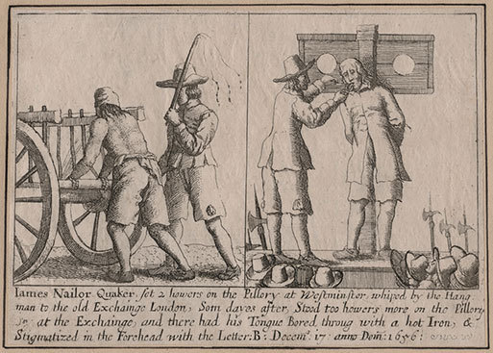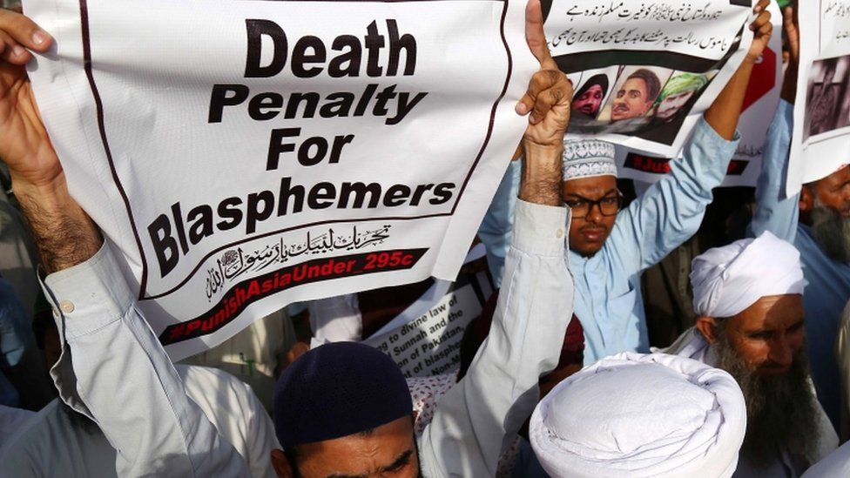
The God of the Hebrew Bible/Old Testament is often shockingly anthropomorphic. He is vulnerable to and insulted by others—as of course is the incarnate son of God, crucified like a criminal on the cross. The Hebrew words that were later translated using the Greek word ‘blasphemy’ mean ‘to insult’, ‘to abuse’, ‘to revile’, ‘to despise’, ‘to curse’, ‘to defame’, and ‘to speak injuriously’. One verb, qillel, comes from the root ‘to make little’: literally, to belittle. Another verb, nakob, comes from the root ‘to pierce’. This verb takes us to the etymology of blasphemy: ‘words that hurt’—or words that bite or sting. Blasphemy is a visceral, social concept, focused on harm to the body, or name. Blasphemy is about those words that prick, or pierce, or poke at humans or gods. And in the Bible, exactly the same verbs—such as qillel, nakob, and blasphēmía—are used of gods and human beings. The New Testament contains statements such as ‘When reviled, we bless; when persecuted, we endure; when blasphemed we speak kindly’ (1 Corinthians 4:12) ‘They are surprised that you no longer join them in the same excesses of dissipation, and so blaspheme you’ (1 Peter 4:4); or ‘Blaspheming them (Paul and Barnabas) they contradicted them’ (Acts 13:45). By using words like ‘slander’ or ‘libel’ for human targets and keeping ‘blasphemy’ for the divine, translators often (but not always) cover over the fact that blasphemy is used for gods and human beings, and comes from imagining gods as if they were (like) human beings.
Note, too, the fuzzy definition of ‘blasphemy’ in these examples. Blasphemy can mean, simply, saying bad words about, or contradicting, someone, taking a different view. And we’ve all met people who can feel ‘blasphemed’ by others not sharing the same practices or convictions, or taking a different view. Those who study blasphemy from other disciplines such as law or history often assume that once-upon-a-religious-time, blasphemy was simple and somehow purely religious, focused on ‘God or sacred things’. The concept came from imagining the gods as social beings, exposed to war, strife, love (and hate), and difficult relationships. Sometimes speakers in the Hebrew Bible address their God in terms that seem rude and disrespectful, even blasphemous, when they urge God to do something. Literally for God’s sake. God’s reputation is tied to his people’s social status. If his people are humiliated, then his God-value index will fall. If for no other reason, he must protect his people for the sake of his reputation, for his good name is tied to the believer community’s good name (Joshua 7:9; Jeremiah 14:21; Ezekiel 20:22; Psalm 74:10, 18). In the Bible, blasphemy can also mean ‘anything that we do or say that causes us, and our god, to be disrespected or mocked by other groups’. When King David forces the married woman, Bathsheba, and then has her husband murdered, this is described by God and his prophet as ‘blasphemy’ against the good name of the community.
In a more uncomfortable biblical example, the author of the New Testament books of 1 Timothy and Titus argues that slaves should submit to their masters and women should submit to men so that the good name of Christianity won’t be blasphemed by the Romans. In this example, blasphemy is a conservative concept. To blaspheme is to give someone, or some god, a bad name: to blacken someone’s name and thus damage someone’s very person, for according to the ancient cultures of West Asia the name is treated the same as the person, and power and life is in the name. In a text from the Nineteenth Dynasty in Egypt (1350–1200 BC), the goddess Isis says to the god Re: ‘Say to me your name, my divine father, for a man lives when someone recites his name.’ According to Exodus 22:28, ‘You shall not blaspheme God or curse a leader of your people.’ Women, slaves, and those who are already low down in the social pecking order can’t be blasphemed.
In Exodus 22:28, God and the human leader reinforce one another, and collectively represent order and authority. Blasphemy is the offence of ‘doing wrong to majesty or sovereignty’, known as the crime of lèse-majesté. What does it mean to protect the name? Here are the two of the Ten Commandments that relate to blasphemy: You shall not make for yourself a pesel [sculpture or statue] whether in the form of anything that’s in heaven above, or that is on the earth beneath.
You shall not bow down to them or worship them; for I the Lord your God am a jealous God. You shall not make wrongful use of the name of the Lord your God, for He will not acquit anyone misusing his name. (Exodus 20: 4–5, 7; Deuteronomy 5: 8, 11) There is both a maximalist and minimalist reading of both commandments. In a minimalist reading of the commandment about God’s name, it’s acceptable to use the name of God in a proper oath—just not to misuse the name, or use it wrongfully. A maximalist or ultra-safe reading—designed to make sure that the commandment is not broken—bans any mention of the divine name.
In Exodus 3:13–15, Moses ‘sees’ god but only in the form of a miraculously burning bush and the sound of the voice of God coming from the fire. Moses asks God for his name and God replies: ‘I am who I am’ or ‘I will be who I will be’: in Hebrew Yahweh, which was written without consonants as the tetragrammaton YHWH. Try to pronounce the word YHWH out loud, without any vowels to help you. The name cannot be spoken—and this is the point. It can only be expressed through code words such as Adonai (‘my Lord’), or Ha-Shem, simply meaning ‘the name’.

Sherwood, Yvonne. Blasphemy: A Very Short Introduction (pp. 47-51). OUP Oxford. Kindle Edition.

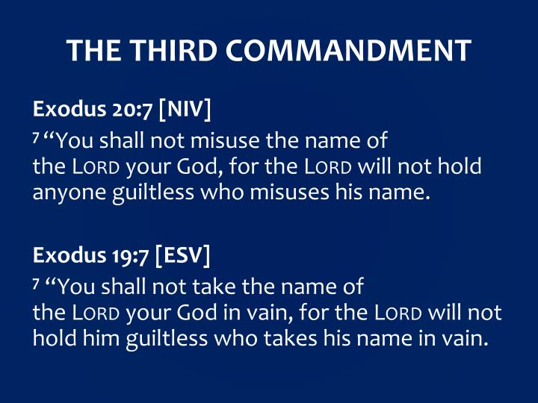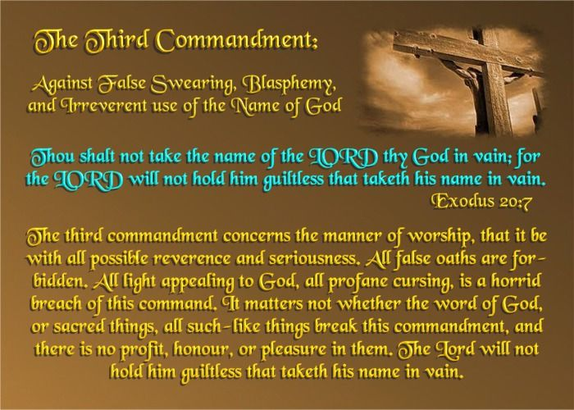

Importance of Names

First thing then before we get into talking about what it means to misuse the name of God, we need a short refresher on names.
One, names have meaning. In the Bible, people were not given names simply because they were trendy or sounded nice. Bible names were given because of the meaning behind those names. The name of God is no different. The name of God is significant because of what that name means.
Two, names define character and reputation. The Hebrew word for name carries with it the meaning of reputation or character. The Hebrew word can rightly be translated to mean any of those things. In the mind of the Hebrew they all point to the same idea. So, in the Old Testament when you talk about someone’s name you are also talking about that person’s character and reputation. Therefore, we could just as easily translate Exodus 20 to say “Do not misuse the character of the LORD…or Do not misuse the reputation of the LORD.”
Three, God’s name—YAHWEH—refers to his continual, ongoing, active presence. God’s name in itself boldly testifies to his continuing faithful and abiding presence. This is an extremely important understanding for the third commandment—that God’s name refers to his active presence with his people.
We need to hold on to that because it will come up as vitally important a bit later as we work our way into applying how the third commandment works.

Misusing the Name of God
What does it mean then to misuse the name of God? Maybe you have always grown up with the simple understanding that misusing God’s name amounted pretty much to using filthy language and any swear words that involve the name of God. And so, by that understanding, keeping the third commandment just meant avoiding bad language with regards to God’s name - but there is more going on here than simply watching your swear words. So, let’s consider how a broader view of this commandment takes shape.
Remember that God’s name also refers to his character and his reputation. When we say things about God that deny or go against his character and reputation then we break the third commandment. It is God’s character to be faithful and abiding in love. When you and I say things that deny this character and reputation of God then we break the third commandment. When other people renounce God’s faithfulness then they misuse the name of the LORD.
But let me take this one step further, because we are talking about more here than just words. What if we never say words that violate God’s character but still live as though we violate God’s character?
What if we never say out loud with our mouths that God is unfaithful, but we live in such a way that our actions say it for us.

Denying the Name of God
The ultimate violation of the third commandment is to live in such a way that denies the very name of God. Remember we talked about how important the meaning of that name is. God’s name testifies to his continual, ongoing, and active presence. God’s name means that he is with us. Not only is God with us; God is active among us.
But let’s be honest now. Can any one of us honestly say that we live every single moment of every single day of our entire lives remembering and affirming that God is continually and actively present with us? Honesty would compel each one of us to admit we do not always acknowledge the active presence of God in our lives. We sometimes forget to seek his counsel. We stumble into sin and wander away from God, and need be returned. God’s name means active presence —he is the I AM—but you and I at times forget that.

Affirming God’s Name
We cannot leave it here though. We have talked about different ways we fall into misusing the name of God by what we say and by what we do.
It is not only a commandment which directs us to avoid saying wrong things about God; it is a commandment which implores us to say the right things about God.
So, consider this now. What is it in your life that boldly testifies to God’s character and reputation? Jesus accuses the Pharisees of hypocrisy; they say one thing, but do another thing. Jesus calls out the religious elite because the words and action of their lives do not line up with what it is they ought to know and believe about God, about God’s character, about God’s reputation. So then, how can we be people who—more align the words and actions of our lives together with God’s character and reputation?
Lifestyle Communicates An Unspoken Blasphemy. It starts with our being aligned. Jesus is calling our attention to something of importance. Religious people can develop a problem with hypocrisy.
The Barna Research group shows with consistently in surveys done over the last decade that the number one reason atheists in America reject the Christian faith has nothing to do with God or the Bible, it has to do with church and other Christians. The barrier which keeps people in this country away from faith is not God, isn’t the Bible, is not the teaching or the doctrines; it’s us—we are the barriers that keep people away from God. The most recent survey Barna conducted on this topic showed that two-thirds of people who left the church and walked away from it - identify the hypocrisy of other Christians as the reason why they left.
AT THE NEXUS OF GRACE & GLORY
Five Steps For Saving:

- HEARING:
- Romans 10: 17; Matthew 7: 24 - 27
- BELIEVING:
- Hebrews 11: 6; Mark 16: 15, 16
- REPENTING:
- Acts 2: 38; 17: 30; Luke 13: 3
- CONFESSING:
- Matthew 10: 32, 33; Acts 8: 36, 37
- BAPTISM:
- Romans 6: 3 – 5; Acts 8: 36 – 38

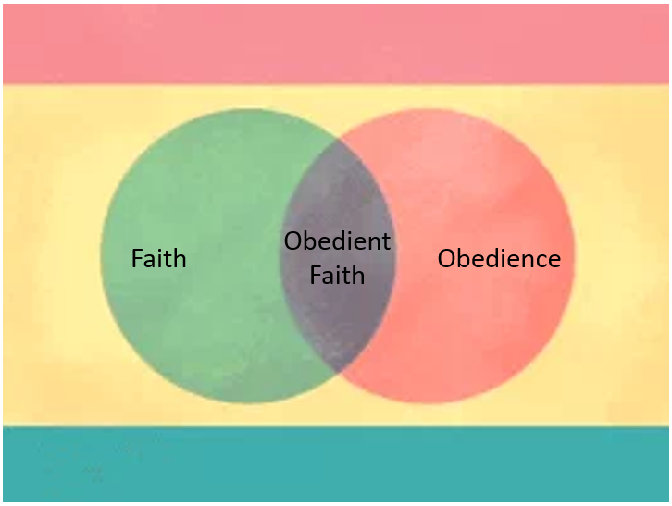

Torrey, R. A. (2001). The new topical text book: A scriptural text book for the use of ministers, teachers, and all Christian workers. Oak Harbor, WA: Logos Bible Software.
Mills, D. W. (2016). Blasphemy. In J. D. Barry, D. Bomar, D. R. Brown, R. Klippenstein, D. Mangum, C. Sinclair Wolcott, … W. Widder (Eds.), The Lexham Bible Dictionary. Bellingham, WA: Lexham Press.

